FULL NAME: Shahzaib Asim

S NUMBER: S2312202

COURSE TITLE: Level 3 Information Technology

TEACHER: Mr I. Chukwuma

Brief Introduction of Learning Aim B
In this Learning Aim I will develop a marketing plan for my IT business idea My chosen business idea is SmartBiz is AI, Website & IT Solutions which will provide AI automation, website development and IT support services for small businesses
The purpose of this business is to help small businesses use technology in a simple and affordable way. Some small businesses may spend a lot of time doing repetitive tasks such as replying to customer questions, sending reminders, organising information and following up with customers. Some may also need a professional website or have technical problems but cannot afford to employ full-time IT staff.
My business will aim to solve these problems by providing several services in one place. These services could include AI chatbots, automated customer replies, booking and reminder automation, website design and development, website maintenance, business email setup, cloud support, basic cybersecurity, software setup and general IT troubleshooting.
Before creating my marketing plan, I will carry out market research to understand the target market, customer requirements and needs, gaps in the market, potential demand, current market trends, competitors, economic climate and business risks, as required in the specification.
I will also assess the business idea by looking at its features and benefits, sustainability, security, usability, financial viability, potential market size and legal requirements. This will help me decide if the idea is realistic and suitable for the market.
The marketing plan will include the characteristics of the service, pricing methods, promotion methods, channels to market and distribution methods. I will also explain how the different parts of the marketing plan work together, how I will carry out market testing and how I will monitor whether the plan is successful.
SELECTING AN IT PRODUCT/SERVICE
Identify IT product/service to create Enterprise
Idea | Main benefit | Main limitation | Overall suitability
AI Automation + Website + IT Support for Small Businesses | Solves several digital problems in one service and can create one-off and recurring income. | Needs strong security, clear scope and continuous learning because AI tools change quickly. | High
Student Study Planner App | Useful for students and easy to create a visual prototype. | Crowded market and a full mobile app would require more development and testing. | Medium
PC Repair and Upgrade Service | Clear technical need and easy to explain to customers. | More hardware, travel, tools and physical stock may be required. | Medium
Before choosing my final enterprise idea, I compared three possible IT products/services. I considered the main benefit, limitations and overall suitability of each idea.
After comparing these ideas, I selected SmartBiz AI, Website & IT Solutions because it provides the strongest balance of customer need, business growth potential and different ways of generating income. The business can earn money from one-off website projects, automation setup and recurring support services.
Product or service features
My selected IT enterprise is SmartBiz AI, Website & IT Solutions. It will be a business to business IT service aimed mainly at micro and small businesses. The service will combine website development, simple AI automation and IT support. This matches the specification requirement to identify an IT product or service that can be developed into an enterprise.
The main purpose of SmartBiz is to help small businesses improve the way they use technology without needing their own full-time IT department. Many small businesses may need a professional website, help with customer enquiries and bookings, simple automation for repetitive tasks, or support when they experience technical problems.
The three main parts of my service are:
- Website Development – creating or improving professional, responsive websites with contact forms, booking or enquiry systems, basic SEO and analytics.
- AI Automation – setting up simple automation such as automatic enquiry acknowledgements, appointment reminders, customer follow-ups and FAQ support.
- IT Support – helping businesses with software setup, business email, cloud services, backups, account security and basic troubleshooting.
The service will meet customer requirements by giving small businesses one provider for several digital needs. Instead of using one company for a website, another company for automation and another company for IT support, SmartBiz can provide these services together.
My original idea gave equal importance to all three services. However, my real market research showed that Website Development had the strongest demand, with 53.3% of respondents selecting it as the most useful service. Therefore, I changed the idea so that website development will be the main starting service, while AI automation and IT support will be available as optional add-ons.
The Unique Selling Point
“Affordable professional websites for small businesses, with simple AI automation and reliable IT support when needed”
This makes the enterprise more focused on the needs shown by my market research while still allowing the business to grow and offer additional IT services in the future.

Sustainability assessment
The sustainability assessment looks at the environmental impact of my proposed IT service, including power usage, waste, equipment, recycling and reuse. These areas are included in the Pearson specification when evaluating an IT product or service idea.
SmartBiz AI, Website & IT Solutions will mainly provide digital and remote services, so it will not need to manufacture physical products. This reduces the need for packaging, materials and large amounts of physical waste. Website development, AI automation and remote IT support can all be carried out online, which may also reduce unnecessary travel.
Remote support can improve sustainability because many website, software, email and cloud problems can be solved without visiting the customer. When an on-site visit is necessary, appointments can be planned efficiently so that unnecessary journeys are avoided.
The business can also encourage customers to repair, upgrade and reuse existing devices where suitable instead of replacing equipment too early. This can help reduce electronic waste. Old IT equipment should be recycled through appropriate recycling services where possible.
However, SmartBiz will still have an environmental impact. Websites, cloud services and AI systems use data centres and electricity, and some AI tasks can require significant computing power. For this reason, I would avoid unnecessary automation, use efficient workflows and choose reliable hosting and cloud providers.
I would also avoid storing unnecessary files and duplicate backups for long periods because digital storage also uses resources. Files and customer data should be kept organised and only retained where there is a clear business or legal reason.
Overall, I believe SmartBiz is a reasonably sustainable business idea because most of the work is digital and can be completed remotely. The main areas I would continue to monitor are energy use, cloud services, travel, electronic waste, recycling and reuse of equipment.
Security assessment
Security is an important part of SmartBiz AI, Website & IT Solutions because the business may have access to customer websites, email accounts, cloud systems, login details and business information. The Pearson specification says a security assessment should consider secure servers, software source control, penetration testing and password protection.
SmartBiz should use secure servers and HTTPS/SSL for websites so that information sent between the website and the user is protected. Customer systems should also use strong passwords and, where possible, multi-factor authentication. Passwords should not be stored in normal documents or messages because this could create a security risk.
For website development, software source control should be used to manage changes to website code. This would make it easier to track updates, restore an older version if something goes wrong and control who is allowed to make changes.
Websites and systems should also be tested before they are launched. Basic security checks can identify weaknesses, while more advanced penetration testing should only be carried out by someone with the correct skills and permission.
AI automation also needs to be controlled carefully. SmartBiz should limit what an automated system is allowed to access and should test the system before using real customer data. Important actions should still be checked by a human where needed.
Overall, security is a major requirement for SmartBiz because a security problem could cause data loss, loss of customer trust or damage to the business reputation. Using secure servers, source control, strong password protection, testing and controlled access will help make the service safer and more reliable.
Usability assessment
Usability is important for SmartBiz AI, Website & IT Solutions because the services need to be easy for small-business owners and their staff to understand and use. The Pearson specification says usability should consider the design of user interfaces and smooth, consistent integration with required systems.
The websites created by SmartBiz should be simple, clear and easy to navigate. They should work properly on mobile phones, tablets and computers. Important information such as services, prices, contact details and booking options should be easy to find. Buttons, menus and forms should be clearly labelled so users do not become confused.
The website design should also consider accessibility. Text should be easy to read, colours should have good contrast, images should include alternative text where appropriate, and the site should be usable with a keyboard where possible. This will make the website more suitable for a wider range of users.
AI automation should also be simple to use. For example, if a business uses an automatic appointment reminder or enquiry response, staff should be able to understand how it works and how to change or stop it if needed. The system should not require complicated technical knowledge.
SmartBiz should also make sure its services integrate smoothly with the customer’s existing systems, such as business email, booking tools, cloud storage or contact forms. Before launch, the website and automation should be tested with users to identify confusing areas or problems.
Overall, good usability will make SmartBiz services easier to understand, reduce mistakes and improve the customer experience. A service that is technically advanced but difficult to use would not meet the needs of small businesses effectively.
Financial assessment
The financial assessment looks at whether SmartBiz AI, Website & IT Solutions is financially viable by considering the likely costs, revenues and whether the business can make enough income to continue operating. The Pearson specification requires the financial assessment to consider the viability of the idea, including revenues and costs.
SmartBiz has a relatively low start-up cost because most of the work can be completed using a laptop and delivered remotely. The business would not need a physical shop or large amounts of stock. However, there would still be costs for software, hosting, security tools, marketing and training.
Estimated early costs could include:
Cost | estimated amount
Business website, domain and email | £80–£150 per year
Hosting and backup tools | £20–£60 per month
AI and automation tools | £30–£120 per month
Remote support/security tools | £20–£80 per month
Initial marketing test | £100–£250
Training and contingency | £200–£400 initially
These are planning estimates and would need to be checked before launching the business.
SmartBiz could generate revenue from both one-off projects and recurring monthly services. Based on my real market research, I would test the following prices:
- Website Starter: £249–£299
- Business Website: £399–£599
- Simple AI Automation Setup: £99–£149 plus any software costs
- IT/Website Care: £39–£49 per month
- Combined Care Package: around £79–£99 per month after setup
My survey showed that 60% of respondents would consider paying under £300 for a basic professional website, while 66.7% would consider paying under £50 per month for ongoing IT or automation support. This shows that customers are price sensitive, so affordable starter packages are important.
The main financial advantage of SmartBiz is that it can earn money from one-off website projects while also building recurring revenue from website care, automation and support packages. Recurring income could make the business more financially stable over time.
However, there is also a financial risk. If the prices are too low or customers require more support than expected, the business could become unprofitable. For example, a £39 monthly support package would not be sustainable if a customer needed several hours of support every month.
To reduce this risk, each package should have a clear scope, limits and additional charges for extra work. I would also track the time and software costs used for each pilot customer and calculate whether each service makes a profit before launching it widely.
Overall, SmartBiz appears financially realistic as a small start-up because the fixed costs are relatively low and there are several possible income sources. However, the final prices should only be kept if the pilot shows that they cover the real cost of delivering the service and still provide a reasonable profit.
Potential size of the market
The potential market for SmartBiz AI, Website & IT Solutions is large because the business is aimed at micro and small businesses, which make up a very large part of the UK private-sector business population. The Pearson specification requires the selected idea to consider the potential size of the market as part of the idea assessment.
My secondary research shows that there were around 5.7 million private-sector businesses in the UK, including about 5.64 million small businesses with 0 to 49 employees. This means small businesses represent more than 99% of the UK private-sector business population.
This creates a large potential market for SmartBiz because many small businesses may need help with areas such as:
- professional website development
- website improvements
- customer enquiry or booking systems
- simple AI automation
- business email and cloud services
- IT support
- cybersecurity and backups
However, SmartBiz would not try to target every small business in the UK at the beginning. The first realistic market would be micro and small businesses in London, especially owner-managed businesses that depend on customer enquiries, bookings and repeat customers. Examples include barbers and salons, restaurants and takeaways, tuition centres, garages, tradespeople, small retailers, clinics and professional services.
My primary research also shows there is potential demand within this market. 53.3% of respondents selected Website Development as the most useful service, and 53.3% either did not have a professional website or said their current website needed improvement. This suggests that website development could provide a realistic starting opportunity for SmartBiz.
There is also some potential for automation. 80% of respondents were either interested or possibly interested in automation, although the low AI comfort score shows that the service would need to be explained simply and introduced carefully.
Overall, the total potential market is very large, but the realistic market for a new SmartBiz enterprise would initially be much smaller. I would begin with a limited number of local small-business sectors, test the service with real customers, build reviews and case studies, and then expand into more sectors and locations if the business is successful.
Legal assessment
SmartBiz AI, Website & IT Solutions must follow relevant laws because the business may handle customer websites, personal information, cloud accounts, software and online services. The Pearson specification states that the legal assessment should consider current and relevant requirements such as data protection legislation, patents legislation and health and safety at work legislation.
One of the most important legal areas is data protection. SmartBiz may process names, email addresses, telephone numbers, website enquiries and other customer information. This means the business must handle personal data lawfully, fairly and securely in line with the UK GDPR and Data Protection Act 2018. Customer information should only be collected when necessary, kept secure and not shared without a valid reason.
If SmartBiz uses contact forms, mailing lists, cookies or direct marketing, the business must also make sure that customers are given clear information about how their data will be used. Marketing messages should not be sent in a way that breaks privacy or electronic communications rules.
Copyright and software licensing are also important. SmartBiz must not copy website designs, photographs, logos, fonts, software or written content without permission. Any templates, plugins, AI tools or software used for customer projects should have the correct licence. Client agreements should also clearly explain who owns the finished website and any content created for it.
For AI automation, SmartBiz should avoid making misleading claims that AI systems are always accurate. Important AI-generated information should be reviewed by a person, especially where an incorrect answer could affect a customer. The business must also follow the terms and conditions of the AI and automation platforms it uses.
Health and safety may also apply if SmartBiz provides support at a customer's premises. Equipment, cables and work areas should be used safely, and unnecessary risks should be avoided. If the business later employs staff, further workplace health and safety responsibilities would need to be followed.
Patents and intellectual property may become more important if SmartBiz develops an original software product or technical invention in the future. Before claiming ownership of a new invention or copying an existing technology, the business should check whether relevant intellectual-property protection already exists.
Overall, legal compliance is important because breaking the law could result in complaints, financial penalties and loss of customer trust. SmartBiz should therefore use clear contracts, protect personal data, follow software licences, respect intellectual property and use safe working practices before providing services to customers.
Research Collateral for Market Research
To support my market research for SmartBiz AI, Website & IT Solutions, I created and planned different types of research collateral. Research collateral is material that helps potential customers understand the service before giving feedback. The Pearson specification says this can include design information such as storyboards, flow charts and infographics, as well as prototype products or services such as websites or computer programs.
Design information
For SmartBiz AI, Website & IT Solutions, I created design information to show how the service would look and how customers would use it. The Pearson specification states that design information for market research can include storyboards, flow charts and infographics.
The main design is a professional SmartBiz website. The website would have a simple layout so that small-business owners can quickly understand the services being offered.
The planned website structure is:
Home → About SmartBiz → Services → Pricing → Portfolio/Examples → Contact
The Home page would introduce SmartBiz and explain the main benefit of the service. It would include the revised USP:
“Affordable professional websites for small businesses, with simple AI automation and reliable IT support when needed.”
The Services page would be divided into three main areas:
- Website Development – professional and responsive business websites.
- AI Automation – automated enquiry responses, reminders and follow-ups.
- IT Support – help with business email, cloud systems, security and technical problems.
The Pricing page would show simple service packages so customers can understand the approximate cost before contacting SmartBiz.
I also designed a simple automation flow chart to explain how one SmartBiz service could work:
Customer sends enquiry → enquiry is received → automatic acknowledgement is sent → business owner is notified → customer details are recorded → follow-up reminder is created
This design is useful because it shows potential customers how automation can reduce repetitive work while still allowing the business owner to stay in control.
A simple website customer journey would be:
Customer visits SmartBiz website → reads services → compares packages → views examples → completes contact form → receives response → consultation takes place
The design information would be shown to potential customers during market research so they can give feedback about the layout, services, pricing, ease of use and whether the idea meets their business needs. Their feedback can then be used to improve the final SmartBiz service before a wider launch.
Prototype
For SmartBiz AI, Website & IT Solutions, I created a website-based prototype to show how the service could work before fully launching the business. The Pearson specification states that prototype evidence can include items such as a website, computer program, computer device or video evidence.
The SmartBiz prototype is designed to give potential customers a clear idea of the services, prices and way the business would operate. The prototype website would include the following main sections:
- Home – introduction to SmartBiz and the main USP.
- About – information about the business and its purpose.
- Services – Website Development, AI Automation and IT Support.
- Pricing – clear starter packages and monthly support options.
- Portfolio / Examples – examples of websites or digital work.
- Contact – enquiry form and contact information.
The prototype would also demonstrate a simple automation process. For example:
Customer sends an enquiry → automatic acknowledgement is sent → business owner is notified → customer details are recorded → follow-up reminder is created.
This helps potential customers understand how the AI automation service could save time and reduce repetitive work.
The prototype is useful for market research because customers can react to something more realistic than just a written description. They can give feedback on the design, ease of use, services, pricing, navigation and whether they would consider using SmartBiz.
Feedback from the prototype can then be used to improve the final service before a wider launch. For example, if users find the website difficult to navigate, the layout can be simplified. If customers do not understand the AI automation service, clearer examples and explanations can be added.
Overall, the prototype reduces the risk of launching a service that customers do not understand or want. It allows SmartBiz to test the idea, make improvements and build a more suitable final service based on customer feedback.
Skills required for marketing a selected IT product/service
Product knowledge
To market SmartBiz AI, Website & IT Solutions effectively, I need strong product knowledge. The Pearson specification states that marketing a selected IT product or service requires skills such as product knowledge, knowledge of the market, understanding customer requirements and needs, and promotional methods.
For SmartBiz, product knowledge means understanding exactly what each service does, what problems it solves, how it benefits the customer and what its limitations are.
I need to understand the three main SmartBiz services:
- Website Development – how professional websites are planned, designed, developed, tested and maintained.
- AI Automation – how simple automation can be used for enquiry responses, reminders, follow-ups and repetitive business tasks.
- IT Support – how to support business email, cloud systems, backups, security and general technical problems.
Good product knowledge is important because customers may ask questions about price, security, features, setup time, support and expected results. I should be able to explain these clearly without using unnecessary technical language.
I also need to understand the limitations of the service. For example, AI automation should not be presented as perfect or fully independent. Some tasks may still need human checking. IT support packages should also have clear limits so customers know what is and is not included.
Product knowledge will help me explain the SmartBiz USP
“Affordable professional websites for small businesses, with simple AI automation and reliable IT support when needed.”
Overall, strong product knowledge will help me market SmartBiz more professionally, answer customer questions confidently and make sure that promotional claims are realistic and accurate.
Knowledge of the market
To market SmartBiz AI, Website & IT Solutions successfully, I need good knowledge of the market. The Pearson specification identifies knowledge of the market as one of the skills required when marketing a selected IT product or service.
The main target market for SmartBiz is micro and small businesses, especially owner-managed businesses that may not have their own IT department. Examples include tuition centres, salons, garages, restaurants, tradespeople, small retailers and professional service businesses.
My market research helped me understand what these customers are looking for. From my 15 genuine survey responses, 53.3% selected Website Development as the most useful service. This showed that website development should be the main service offered by SmartBiz, with AI automation and IT support available as additional services.
I also learned that customers in this market are price sensitive. My survey showed that 60% would consider paying under £300 for a basic professional website, while 66.7% would consider paying under £50 per month for ongoing IT or automation support. This information helped me create affordable starter packages rather than setting prices that may be too high for small businesses.
I also need to understand how customers prefer to find IT providers. My research showed that Google was the most popular method, selected by 53.3% of respondents, followed by referrals. Therefore, SmartBiz should focus strongly on its website, Google visibility, local SEO and customer reviews.
Understanding competitors is also important. SmartBiz may compete with freelance web developers, website-building platforms and local IT support companies. I need to understand their services, prices, strengths and weaknesses so that SmartBiz can offer something different. The main difference will be providing website development, simple AI automation and IT support through one business.
Knowledge of current market trends is also necessary because technology changes quickly. Small businesses are increasingly using websites, cloud services and automation, but my research also showed that many respondents were not very comfortable with AI. Therefore, SmartBiz should explain AI in simple language and focus on practical benefits rather than using complicated technical terms.
Overall, good knowledge of the market will help me identify the right customers, set suitable prices, choose effective promotional methods and adapt SmartBiz services to what small businesses actually need.
Understanding customer requirements and needs
To market SmartBiz AI, Website & IT Solutions successfully, I need to understand what customers actually need before offering them a service. The Pearson specification identifies understanding customer requirements and needs as an important skill when marketing a selected IT product or service.
For SmartBiz, customer requirements can be different depending on the type of business. Some customers may need a new professional website, while others may already have a website but need improvements. Other customers may need help with bookings, customer enquiries, follow-ups, cloud systems or technical support.
My market research helped me identify these needs. 53.3% of respondents either did not have a professional website or said their current website needed improvement, which shows that website development is a clear customer requirement.
The survey also showed that 80% of respondents were either interested or possibly interested in automating reminders, enquiry acknowledgements or follow-ups. However, many respondents were not confident using AI, so customers may need automation that is simple, easy to understand and still controlled by a person.
Price is also an important customer requirement. My research showed that 60% would consider paying under £300 for a basic professional website, while 66.7% would consider paying under £50 per month for ongoing support. This means SmartBiz should provide affordable starter packages with clear prices and clear limits.
Customers also need trust, security and reliability. Because SmartBiz may work with websites, email accounts and cloud systems, customers need to know that their information will be protected and that the service will be dependable.
To understand customer needs before starting a project, I would ask questions such as:
- What problem are you trying to solve?
- What features do you need?
- What is your budget?
- Who will use the website or system?
- Do you already use any software or cloud services?
- How much support do you need after the project is completed?
Overall, understanding customer requirements will help SmartBiz provide the right service instead of offering the same package to every customer. This should improve customer satisfaction, reduce misunderstandings and make the service more useful to each business.
Promotional methods
To market SmartBiz AI, Website & IT Solutions effectively, I need to understand which promotional methods are most suitable for the target market. The Pearson specification identifies promotional methods as one of the skills needed when marketing a selected IT product or service.
SmartBiz should mainly use digital promotion because its target customers are small businesses looking for website and IT services. The main promotional methods I would use are:
- Business website – the SmartBiz website would explain the services, prices, benefits, examples of previous work and contact details.
- Google and local SEO – this would help small businesses find SmartBiz when searching for services such as website development or local IT support.
- Google Business Profile – this can improve local visibility and allow customers to leave reviews.
- Customer referrals – satisfied customers could recommend SmartBiz to other business owners.
- Online reviews and testimonials – genuine customer feedback can build trust and show that the service is reliable.
- LinkedIn – useful for connecting with business owners and promoting website and IT services.
- Direct email – carefully targeted emails could be sent to relevant businesses, provided that privacy and marketing rules are followed.
- Social media – platforms can be used to show website examples, before-and-after improvements and simple explanations of AI automation.
- Local networking – meeting business owners through local events can help build trust and generate leads.
My primary market research showed that Google was the most preferred method for finding an IT provider, selected by 53.3% of respondents. Referrals were the second strongest method. Therefore, I would give the highest priority to Google visibility, local SEO and customer referrals rather than spending heavily on general social-media advertising.
The promotional message should also be simple and focused on customer benefits rather than technical language. For example:
“Affordable professional websites for small businesses, with simple AI automation and reliable IT support when needed.”
Overall, using the correct promotional methods will help SmartBiz reach the right customers, build trust and increase enquiries. I would monitor which methods generate the most enquiries and paying customers, then invest more in the channels that perform best.
MARKET RESEARCH

Qualitative and quantitative factors that affect the market for an IT product/service
Introduction:
For SmartBiz AI, Website & IT Solutions, market research is important because it helps me understand whether there is enough demand for the service and what small businesses actually need. The Pearson specification states that market research should consider both qualitative and quantitative factors, including the target market, customer requirements, gaps in the market, current trends, competitors, the economic climate and business risks.
For this project, I used both primary and secondary research. My primary research included a questionnaire completed by 15 respondents, while my secondary research used information from reliable business, technology and government sources.
The quantitative research gave me numerical information such as percentages, preferred services, price ranges and promotional channels. The qualitative side focused more on customer attitudes, confidence, trust, security concerns and reasons behind their choices.
This research helped me understand the market better and make more informed decisions about the services, pricing, promotion and target customers for SmartBiz.
Target market
The main target market for SmartBiz AI, Website & IT Solutions is micro and small businesses in London that use digital systems but do not have a large internal IT team. My first target segment will be owner-managed service businesses with around 1 to 20 employees, because these businesses may need outside support and the owner or manager can often make purchasing decisions quickly.
Possible customers include:
- barbers and salons
- restaurants and takeaways
- tuition centres
- garages
- tradespeople
- small retailers
- clinics
- accountants
- other local professional service businesses
A second target segment will be new start-up businesses that may need a professional website, business email and simple automation from the beginning.
The main decision maker is likely to be the business owner, manager or person responsible for technology. Therefore, SmartBiz marketing should use simple language and focus on practical benefits such as saving time, reducing costs, improving reliability and protecting business data, rather than using complicated technical terms.
My primary research also supports a website-led target market. 53.3% of respondents selected Website Development as the most useful service, and 8 out of 15 respondents either did not have a professional website or said their current website needed improvement. This suggests that small businesses needing a new or improved website should be one of the main groups targeted first.
Overall, SmartBiz should begin with a narrow local market rather than targeting every UK business immediately. Starting with small London businesses will make it easier to test the service, build customer reviews and improve the offer before expanding to a wider market.
Customer requirements and needs
For SmartBiz AI, Website & IT Solutions, it is important to understand what small businesses actually require before deciding which services to offer. The Pearson specification states that market research should consider customer requirements and needs as one of the main factors affecting the market.
The main customer requirements identified for SmartBiz are affordable pricing, simple setup, reliable support, clear explanations, data security and measurable business benefits. Some customers may also prefer using one provider for several digital problems instead of dealing with different companies for websites, automation and IT support.
My primary research helped show which needs are most important. 53.3% of respondents either did not have a professional website or said their current website needed improvement, while 53.3% selected Website Development as the most useful SmartBiz service. This shows that professional and affordable website development is one of the strongest customer needs in my sample.
Customers also showed interest in automation. 80% of respondents were either interested or possibly interested in automating tasks, such as reminders, enquiry acknowledgements and follow-ups. However, AI confidence was low, with many respondents feeling uncomfortable using AI. This means customers need automation that is simple, clearly explained and supported by human control, rather than complicated systems they do not understand.
Price is another important requirement. 53.3% said price was the most important factor when choosing an IT provider, while 60% would consider paying under £300 for a basic website and 66.7% would consider paying under £50 per month for ongoing support. Therefore, SmartBiz should provide affordable starter packages with clear limits and transparent pricing.
Overall, SmartBiz customers need services that are affordable, easy to understand, secure, reliable and useful to their business. The business should not assume that every customer wants the same package. Instead, it should identify each customer’s problem first and then offer the most suitable website, automation or support service.
Gaps in the market and the potential demand opportunities
A possible gap in the market for SmartBiz AI, Website & IT Solutions is the combination of website development, simple AI automation and ongoing IT support for small businesses. Many existing services focus on only one area. For example, website builders such as Wix and GoDaddy mainly help customers build websites, while CRM platforms such as HubSpot focus more on customer management and automation. Some small businesses may still need a person who can select, configure and support these tools for them.
This creates an opportunity for SmartBiz to offer a more personalised and support-led service. Instead of only giving customers access to software, SmartBiz can help them set up the service, explain how it works and provide support when they need help.
My market research also shows possible demand for website services. Website problems were the largest single digital difficulty at 40%, and 53.3% of respondents selected Website Development as the most useful service. Also, 53.3% either did not have a professional website or said their current website needed improvement. This suggests that affordable website creation and improvement could be a strong demand opportunity.
There is also potential demand for automation. 80% of respondents were either interested or possibly interested in automating tasks, such as reminders, enquiry acknowledgements and follow-ups. However, AI comfort was low, so the opportunity is stronger for simple automation that is easy to understand rather than complex AI systems.
The IT support opportunity is more limited in my current sample because 80% of respondents already have a person or company providing regular IT support, and only 6.7% selected IT Support as the most useful SmartBiz service. Therefore, IT support should be offered mainly as an optional add-on, backup service or alternative for businesses that are unhappy with their current provider, rather than being the main product at launch.
Overall, the main gap SmartBiz can target is small businesses that want affordable, practical and personalised digital support from one provider. The strongest initial opportunity is website development, followed by simple automation, with IT support available when needed.
Current market trends
Current market trends are important for SmartBiz AI, Website & IT Solutions because technology changes quickly and small businesses are using more digital tools.
One important trend is the growing use of AI and automation. Government research published in 2026 found that around one in six UK businesses were using at least one AI technology, although adoption was lower among micro businesses than larger organisations. This creates an opportunity for SmartBiz to help small businesses use simple automation for tasks such as customer enquiries, reminders and follow-ups.
Another trend is the continued use of cloud software, CRM systems and productivity tools. Small businesses increasingly use online systems for email, file storage, customer management and communication. However, some businesses may not know which tools are suitable or how to set them up correctly. SmartBiz could help by selecting, setting up and supporting suitable digital systems.
Website creation is also becoming easier because platforms such as Wix and GoDaddy now provide AI-assisted website-building tools. This increases competition because some businesses can create a basic website themselves. Therefore, SmartBiz should not compete only by offering website creation. It should provide extra value through personal setup, integration, automation, security and ongoing human support.
Overall, these trends create both opportunities and threats for SmartBiz. AI, cloud services and digital tools create more demand for technology support, but self-service platforms also make the market more competitive. SmartBiz therefore needs to focus on affordable, simple and personalised services that are easy for small-business owners to understand.
Competitor analysis
Competitor analysis is important for SmartBiz AI, Website & IT Solutions because customers already have different options for websites, automation and IT support. Pearson includes competitor analysis as one of the main market factors that should be researched.
The main competitors for SmartBiz are Wix, GoDaddy, HubSpot, local website agencies and local IT support companies. Each competitor has different strengths and weaknesses
Competitor | Strengths | Weakness / opportunity for SmartBiz
Wix | Easy website creation, hosting, AI website tools and marketing features in one platform. | Mainly self-service, so some small businesses may still need personal setup, integration and ongoing help.
GoDaddy | Provides domains, hosting, website building and AI-assisted business tools. | Customers still need to choose, configure and manage many parts themselves, and general IT support is limited.
HubSpot | Strong CRM, customer management and automation features. | It may be more complex than a very small business needs and does not replace general website or IT support.
Local website agencies | Can provide customised professional websites and local customer service. | Some focus mainly on website design and may not provide automation or wider IT support.
Local IT support companies | Strong technical knowledge and ongoing business IT support. | Some may not specialise in website development or simple AI automation for very small businesses.

This analysis shows that SmartBiz should not claim that it has no competitors. Instead, its competitive advantage should come from offering a combination of services with simple packages, personalised support and one main technology contact for the customer
SmartBiz should also avoid trying to compete with Wix or GoDaddy only on basic website creation because these platforms can already offer low-cost self-service websites. Instead, SmartBiz can provide extra value by helping the customer with setup, integration, security, automation and ongoing human support.
Overall, the competitor analysis suggests that the strongest position for SmartBiz is to target small businesses that do not want to manage all their technology themselves. The business can compete by being easier to understand, more personal and more flexible than large self-service platforms
Economic climate
The economic climate can affect SmartBiz AI, Website & IT Solutions because small businesses may reduce or delay spending when their costs are high or cash flow is uncertain. In your assignment, this means SmartBiz must show customers that the service gives clear value for money and is not just an extra expense
For example, a small business may be interested in a new website or automation, but if money is tight it may choose to delay the purchase. Because of this, SmartBiz should offer affordable starter packages, flexible options and small-scale pilots so the customer does not need to make a large financial commitment at the beginning
The economic climate also affects how SmartBiz should explain its services. Instead of only saying that automation is modern technology, SmartBiz should show how it could save staff time, improve customer follow-up or reduce repetitive work. If the benefit is clear, the customer may be more willing to pay for it
However, SmartBiz must also protect its own finances. Prices should not be set too low just to attract customers because software subscriptions, hosting and support time still cost money. If the price is too low, the business could become unprofitable even if it gains customers.
Overall, the economic climate means SmartBiz should focus on value, affordability and flexibility. Low-cost entry packages can reduce customer risk, but the final prices must still cover the real cost of providing the service.
Business risks
Business risks are problems that could stop SmartBiz AI, Website & IT Solutions from operating successfully or could cause financial loss, customer complaints or damage to the business reputation The Pearson specification says that business risks should be considered as part of market research.
Some important risks for SmartBiz are
Business risk | Possible impact | How SmartBiz could reduce the risk
Cybersecurity or data breach | Customer information could be lost or exposed, causing legal problems and loss of trust. | Use MFA, strong passwords, access controls, backups, updates, contracts and suitable cyber insurance as the business grows.
Incorrect AI output or automation mistake | A customer may receive wrong information or an automated process may perform the wrong action. | Test automations carefully, limit permissions and use human approval for important actions.
Strong competition | Customers may choose cheaper self-service platforms or more established IT providers. | Compete through personalised support, integration and clear business outcomes rather than price alone.
Under-pricing and scope creep | Projects could take longer than expected and become unprofitable. | Use written project scopes, package limits, change requests and time tracking.
Dependence on third-party platforms | A price increase, outage or policy change from another provider could affect SmartBiz services. | Use reputable providers, back up/export data where possible and avoid unnecessary platform lock-in.
Cash-flow problems | SmartBiz may struggle to pay software or business costs before customer payments are received. | Use deposits for projects, monthly payments, low fixed costs and keep a cash reserve.
Skills gaps | SmartBiz may accept work that cannot be completed safely or professionally. | Use training, certifications, outsourcing and refuse specialist work that is outside current competence.

Overall SmartBiz cannot remove every business risk but it can reduce them through good planning, security controls, clear customer agreements, careful pricing, backups and continuous skills development Risk should be monitored regularly because the business uses fast changing technologies such as AI and cloud services.

Conducting market research
Planning research (define purpose and set objectives)
The purpose of my market research is to find out whether SmartBiz AI, Website & IT Solutions would be useful to small businesses before I spend more money developing and promoting the service. I used Google Forms as my main primary research method and received 17 genuine responses.
The research is designed to help me understand what potential customers need which services they are most interested in, what prices they are willing to pay and how they prefer to find an IT provider. This will help me make my marketing plan based on evidence rather than assumptions.
My research objectives are to
- find out whether businesses already have a professional website or need one improved
- identify the main digital problems small businesses experience
- find out how many businesses already have regular IT support
- measure interest in AI automation such as reminders, enquiry acknowledgements and follow-ups
- understand how comfortable businesses are with using AI
- identify which SmartBiz service would be most useful
- find out what factors are most important when choosing an IT provider
- find out what customers are willing to pay for a professional website
- find out what customers are willing to pay for monthly IT or automation support
- identify the preferred promotional channels, such as Google or referrals
- collect customer comments about tasks or IT problems they would like to make easier
The results from these objectives will be used to shape the service offer, pricing, promotion and market-testing decisions in the final marketing plan.
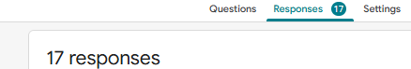

Data Collected (primary and/or secondary data)
For my market research, I collected both primary data and secondary data.
My main primary research was a Google Forms questionnaire, which received 17 genuine responses. The survey collected mostly quantitative data so that I could compare answers using totals and percentages. It asked respondents about their current website, their biggest digital problems, regular IT support, repetitive admin tasks, interest in automation, confidence using AI, preferred SmartBiz service, important factors when choosing an IT provider, website budget, monthly support budget and preferred promotional channel.
The Google Forms results showed that 58.8% selected Website Development as the most useful service, while 23.5% selected AI Automation, 5.9% selected IT Support and 11.8% selected the Combined Package. The survey also showed that 52.9% would consider paying under £300 for a basic professional website, while 58.8% would consider paying under £50 per month for ongoing IT or automation support. For promotion, 52.9% preferred Google and 29.4% preferred referrals.
The questionnaire also collected some qualitative data through an open question. One respondent said they wanted help with “AI replies to customers and improve website.” This supports the idea that website improvement and simple automation could both be useful parts of SmartBiz.
I also used secondary research from existing sources including GOV.UK business information government research on SME digital and AI adoption, ICO guidance and competitor websites such as Wix, GoDaddy and HubSpot. This secondary research helped me understand the wider market, current trends, legal requirements and competitor activity.
Using both types of data is useful because the primary research shows what my own respondents think, while the secondary research gives wider market information. Together, they provide stronger evidence for decisions about SmartBiz’s services, prices and promotion.
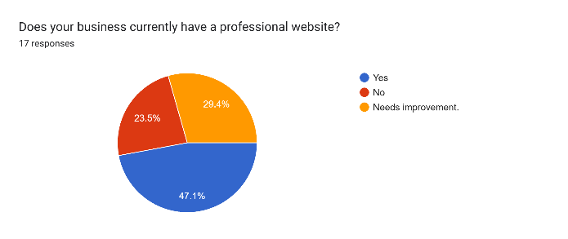 | 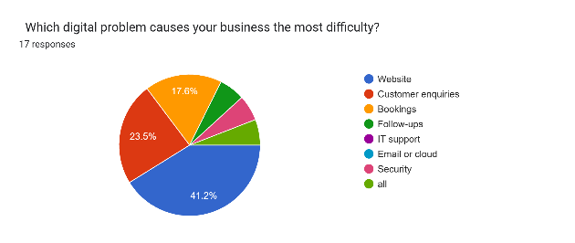
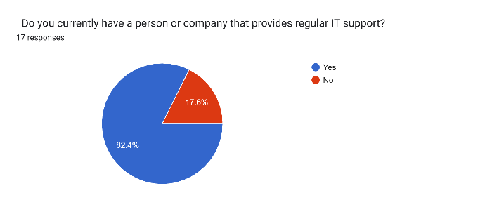 | 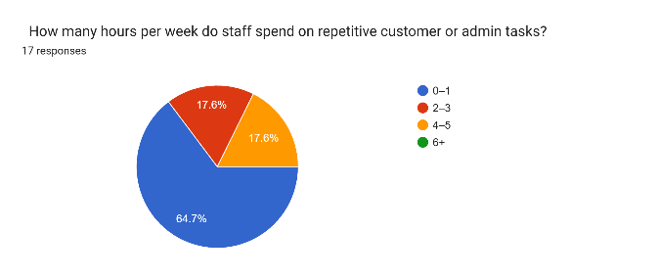
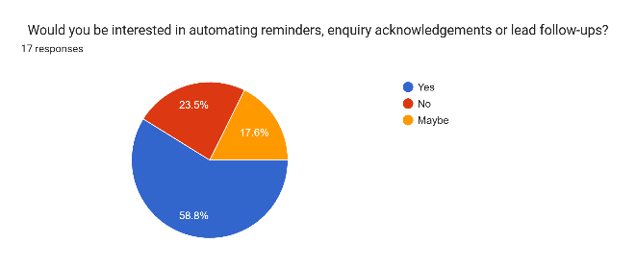 | 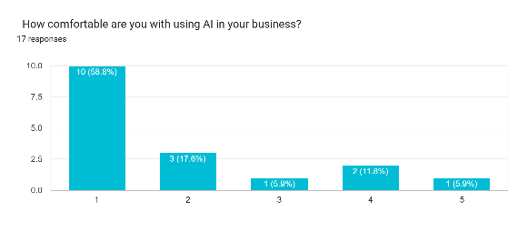
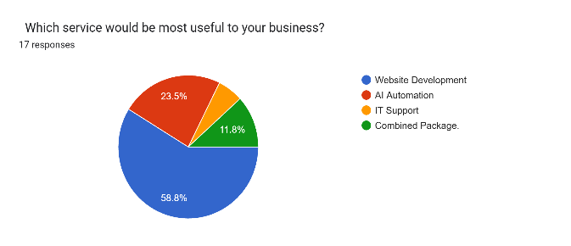 | 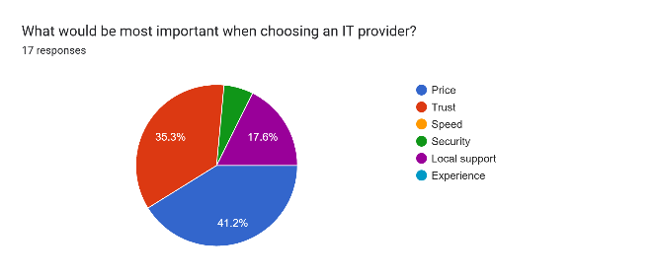
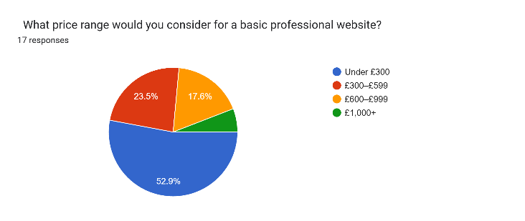 | 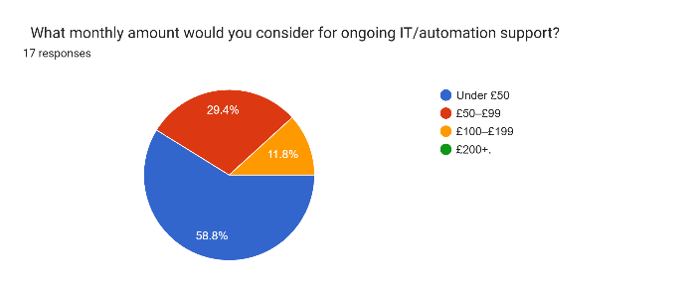
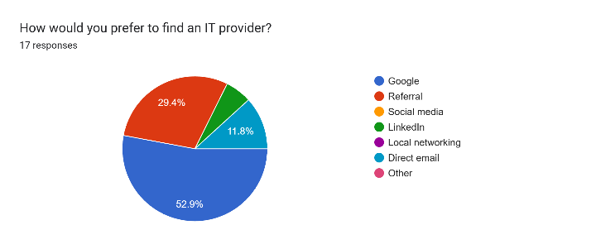 | 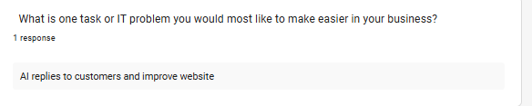

Methods of data collection
For my primary research, I used a Google Forms questionnaire. I shared the survey with potential respondents and received 17 genuine completed responses. Google Forms was useful because it allowed me to collect answers in a consistent format and automatically produced charts and percentages that made the results easier to compare and analyse.
The questionnaire mainly used closed questions such as multiple-choice answers, price ranges, Yes/No options and a 1–5 rating scale. These questions produced quantitative data, which allowed me to calculate percentages and identify patterns. I also included one open question so respondents could explain an IT problem or task they wanted to make easier, giving me some qualitative information.
For my secondary research, I used reliable existing sources such as GOV.UK, government reports about SME technology and AI adoption, ICO guidance and official competitor websites. These sources helped me research the wider market, competitors, technology trends and legal requirements.
Using both primary and secondary research gave me a better understanding of the market. The Google Forms survey gave me direct information from my own respondents, while the secondary research gave me wider information about the business environment. However, because my survey only had 17 responses, the results should be used to guide a small pilot rather than being treated as proof of the whole market.
Carrying out research
sample size
For my primary research, I received 17 completed responses through Google Forms. This means my final sample size was 17 respondents.
My original aim was to collect more responses, but 17 responses were enough to identify some useful patterns for this assignment, such as which services people preferred, what prices they were willing to pay and how they preferred to find an IT provider.
However, the sample size is still quite small compared with the total number of small businesses in London and the UK. Because of this, I cannot say that the results represent every small business. I will use the findings to guide the first version of the SmartBiz marketing plan and support a small pilot, rather than treating the survey as final proof of market demand.
The small sample size is therefore useful for early decision-making, but a larger and more targeted sample would make the research more reliable in the future.
sample method
For my primary research, I mainly used convenience sampling. This means I shared the Google Forms survey with people who were reasonably easy for me to contact and asked them to complete it.
The questionnaire was designed for people who could give useful opinions about small-business technology needs, but the survey did not collect detailed information such as business sector, company size or exact location. Because of this, the sample may not fully represent all small businesses in London or the UK.
Convenience sampling was suitable for this college assignment because it was quick, practical and low cost. However, it can create bias because the people who responded may have similar backgrounds or experiences.
If I repeated the research, I would improve the sample by using more purposive sampling, where I would deliberately target owners or managers from different types of small businesses, such as restaurants, salons, garages, tuition centres and professional services. This would make the results more relevant to the SmartBiz target market and improve the reliability of the research.
Questionnaires
For my primary research, I created a Google Forms questionnaire to collect information from potential customers. The questionnaire used mainly closed questions so that the answers could be compared easily using totals, percentages and charts.
The questionnaire asked about
- whether the respondent already had a professional website
- their main digital problem
- whether they already had regular IT support
- how much time they spent on repetitive admin tasks
- whether they were interested in automation
- how comfortable they were with using AI
- which SmartBiz service would be most useful
- what factor was most important when choosing an IT provider
- how much they would consider paying for a professional website
- how much they would consider paying each month for ongoing support
- how they would prefer to find an IT provider
- one open question asking which task or IT problem they would most like to make easier.
I received 17 completed responses. Using Google Forms was useful because it automatically organised the answers and created charts, making the quantitative data easier to analyse.
One advantage of the questionnaire is that every respondent received the same questions, which makes the results easier to compare. However, most questions were closed questions, so they did not always explain why respondents chose a particular answer. The open question was included to collect more detailed qualitative feedback, but only limited written feedback was received.
Overall, the questionnaire was a practical and low-cost method for collecting primary research and helped me make decisions about SmartBiz’s services, pricing and promotional methods.
Surveys
For my primary research, I used an online survey through Google Forms. The survey received 17 genuine responses from respondents.
The survey was designed to collect information that would help me decide whether SmartBiz AI, Website & IT Solutions had potential in the market. It asked about website needs, digital problems, current IT support, repetitive admin work, interest in automation, AI confidence, preferred services, pricing and preferred ways of finding an IT provider.
The Google Forms survey was useful because it automatically presented the responses using charts, totals and percentages. This made it easier for me to compare the answers and identify patterns.
For example, the survey showed that:
- 58.8% selected Website Development as the most useful service
- 52.9% would consider paying under £300 for a professional website
- 58.8% would consider paying under £50 per month for ongoing support
- 52.9% preferred Google when looking for an IT provider
- 76.4% answered Yes or Maybe when asked about interest in automation
These results helped shape the SmartBiz marketing plan by showing that the business should focus mainly on affordable website development, with AI automation and IT support offered as additional services.
A limitation of the survey is that there were only 17 responses, so the findings cannot represent every small business in London or the UK. Therefore, I would use the results to guide a small pilot and collect more responses before expanding the business.
Interpreting research findings
After collecting the 17 Google Forms responses, I analysed the results to identify the main patterns and what they mean for SmartBiz AI, Website & IT Solutions.
The strongest finding was that Website Development had the highest demand. 10 out of 17 respondents (58.8%) selected Website Development as the most useful service. This suggests that SmartBiz should make website development the main service when the business launches.
Interest in AI automation was also reasonably strong. 10 respondents (58.8%) said Yes and 3 respondents (17.6%) said Maybe when asked whether they would be interested in automating tasks. This means 76.4% were at least open to automation. However, AI confidence was low, with many respondents choosing the lower end of the 1–5 scale. This means SmartBiz should explain AI in simple language and offer automation as an optional add-on rather than making it the main service.
The pricing results also showed that customers are price sensitive. 52.9% said they would consider paying under £300 for a basic professional website, while 58.8% preferred to pay under £50 per month for ongoing IT or automation support. This suggests that SmartBiz should start with affordable entry-level packages.
The survey also showed that Google was the most popular way to find an IT provider, chosen by 52.9% of respondents. Referrals were second at 29.4%. This means the marketing plan should focus strongly on Google, local SEO, customer reviews and referrals.
Another important result was that 14 out of 17 respondents (82.4%) already had regular IT support. This suggests that standalone IT support may be a weaker first service than originally expected. SmartBiz should therefore use IT support as an extra service rather than the main way to attract new customers.
Overall, the research suggests that the best starting position for SmartBiz is to lead with affordable website development, then offer simple AI automation and IT support as optional add-ons. The findings are useful for planning the service, pricing and promotion, but because the sample only included 17 respondents, I would still test the idea with a small pilot before making a larger investment.
Presentation of findings
I presented the findings from my 17 Google Forms responses using charts, percentages, totals and written explanations. Google Forms automatically created visual charts, which made it easier to compare the answers and identify the strongest patterns.
The main findings were
Research area | Main finding
Professional website | 52.9% either had no professional website or said their website needed improvement
Main digital problem | 41.2% selected website problems as their biggest issue
Regular IT support | 82.4% already had regular IT support
Interest in automation | 76.4% answered Yes or Maybe
Most useful service | 58.8% selected Website Development
Website budget | 52.9% preferred under £300
Monthly support budget | 58.8% preferred under £50
Preferred marketing channel | 52.9% selected Google
Second strongest channel | 29.4% selected referrals

I also used written analysis underneath the charts to explain what each result meant for SmartBiz. For example, the high demand for Website Development supports a website-first launch, while the low AI confidence shows that AI should be explained simply and offered as an optional service.
Presenting the results in tables, charts and short explanations makes the research easier for a third party to understand. It also shows clearly how the survey findings influenced the final marketing decisions for SmartBiz AI, Website & IT Solutions.
Conclusions
From my market research, I can conclude that SmartBiz AI, Website & IT Solutions has potential, but the business should start with a focused and affordable service rather than trying to offer everything equally from the beginning.
The strongest opportunity is Website Development. In my Google Forms survey, 10 out of 17 respondents 58.8% selected Website Development as the most useful service, and 52.9% either did not have a professional website or said their current website needed improvement. This suggests that website development should be the main service when SmartBiz launches.
There is also potential for AI automation, because 76.4% of respondents answered Yes or Maybe when asked if they were interested in automating tasks. However, many respondents had low confidence in using AI. Therefore, AI should be offered as a simple optional add-on, with clear explanations and human support.
The research also showed that customers are price sensitive. 52.9% preferred to pay under £300 for a basic professional website, while 58.8% preferred ongoing support costing under £50 per month. This means SmartBiz should begin with affordable starter packages, but the prices must still cover the real cost of providing the service.
For promotion, Google was the strongest channel at 52.9%, followed by referrals at 29.4%. Therefore, SmartBiz should focus mainly on Google, local SEO, customer reviews and referrals.
Overall, my research supports a website-first business model, with AI automation and IT support offered as additional services. However, because the survey only had 17 responses, I would test the business with a small pilot before investing heavily or expanding.
Recommendations
Based on the results of my market research, I would recommend that SmartBiz AI, Website & IT Solutions starts with a website-first approach. Website Development was the most popular service in my survey, selected by 58.8% of respondents, so this should be the main service promoted at launch.
I would recommend offering AI automation as an optional add-on rather than the main service. Although 76.4% of respondents said Yes or Maybe to automation, confidence in using AI was low. This means SmartBiz should explain AI in simple language, demonstrate how it works and keep human checking for important tasks.
The business should also use affordable starter pricing. Since 52.9% preferred to pay under £300 for a basic website and 58.8% preferred monthly support under £50, SmartBiz should test lower-cost starter packages first. However, prices should still cover software, hosting and support time.
For promotion, I would recommend focusing mainly on Google and referrals. Google was the strongest preferred channel at 52.9%, while referrals were second at 29.4%. SmartBiz should therefore invest in local SEO, Google Business Profile, customer reviews and referral incentives before spending heavily on other channels.
I would also recommend carrying out a small paid pilot with around 3–5 businesses before a wider launch. This would help test whether customers are willing to pay, how long projects take, whether the pricing is profitable and which services create the most value.
Finally, I would recommend carrying out a larger and more targeted survey in the future. The current sample of 17 responses is useful for identifying early patterns, but more responses from actual small-business owners and managers would make the findings more reliable.
Limitations of research
Although my market research gave useful information for SmartBiz AI, Website & IT Solutions, there were several limitations.
The main limitation was the small sample size. I received 17 completed Google Forms responses, which is enough to identify some early patterns, but it is too small to represent all small businesses in London or the UK. Because of this, the findings should be used to guide a small pilot rather than treated as final proof of market demand.
Another limitation was the sampling method. I mainly used convenience sampling, so the respondents were people who were reasonably easy to contact. This may create bias because the sample may not include enough different business sectors, locations or company sizes.
The questionnaire also had limited qualitative data. Most questions were closed questions, which were useful for percentages and comparisons, but they did not always explain why respondents selected a particular answer. Only limited written feedback was collected from the open question.
The survey also did not collect detailed information such as each respondent's business sector, business size or exact location. This makes it harder to know whether certain results are stronger in one type of business than another.
Another limitation is that the questionnaire measured what people said they might do, not what they did. For example, someone may say they would pay under £300 for a website, but that does not guarantee they would buy the service.
To improve the research in the future, I would collect a larger and more targeted sample, include more small-business owners and managers from different industries, carry out short interviews, and test SmartBiz with a small paid pilot of 3–5 businesses. This would give stronger evidence about real customer behaviour, pricing and demand.
THE MARKETING PLAN
Brief Introduction
This marketing plan is for my business idea, SmartBiz AI, Website & IT Solutions. The purpose of the plan is to explain how I will promote and sell the service to small businesses using the evidence collected from my market research.
My Google Forms survey received 17 genuine responses. The results showed that Website Development was the most popular service, selected by 58.8% of respondents. The research also showed interest in AI automation, but confidence in using AI was low. Because of this, SmartBiz will use a website-first approach, with simple AI automation and IT support offered as additional services.
The marketing plan will cover the service characteristics and USP, pricing, promotional methods, channels to market, distribution, market testing and methods for monitoring performance. These are the main components required for the marketing plan
The main aim is to attract small businesses by offering affordable professional websites, personalised support and simple technology solutions. The decisions in this plan will be linked to the results of my market research so that the marketing strategy is based on customer needs rather than assumptions.
Components of a marketing plan
The marketing plan for SmartBiz AI, Website & IT Solutions will include the main areas needed to explain how the business will attract customers and sell its services.
The main components are:
- Product or service characteristics – what SmartBiz offers, the main benefits, and the USP/UVP.
- Pricing methods – how much customers will pay and why the prices are suitable for the target market.
- Promotion – how SmartBiz will advertise and communicate with potential customers.
- Channels to market and distribution methods – how customers will find, buy and receive the service.
- Interrelationships between the components – how the service, price, promotion and distribution work together.
- Market testing – how SmartBiz will test the service before a wider launch.
- Monitoring effectiveness – how the business will measure whether the marketing plan is working.
For SmartBiz the plan will be based on the findings from the 17-response Google Forms survey. For example, because Website Development was the strongest service preference, the product strategy will be website-first. The pricing, promotion and market-testing decisions will also be linked to the survey results so that the different parts of the marketing plan are consistent with each other.
Product or service characteristics
The main service offered by SmartBiz AI, Website & IT Solutions will be professional website development for small businesses. My market research showed that Website Development was the strongest service preference, so the business will use a website-first approach rather than trying to promote every service equally.
SmartBiz will provide services such as:
- professional website design and development
- mobile-friendly website layouts
- website maintenance and updates
- business email and basic cloud setup
- simple AI automation, such as enquiry replies, reminders and follow-ups
- basic IT support when required
The main target market will be micro and small businesses, especially businesses that do not have a large internal IT team and need affordable outside support. My research also showed that customers value simple setup, affordable prices, clear explanations, reliability and security
The USP/UVP of SmartBiz will be
“Affordable professional websites for small businesses, with simple AI automation and reliable IT support when needed.”
This means SmartBiz will not compete only by building websites. The business will offer extra value through personal support, setup, integration, automation and ongoing help. This is important because competitors such as Wix and GoDaddy already provide self service website tools.
The service will also be flexible. Customers will not be required to buy every service together. They could start with a website and later add AI automation or IT support if they need it. This makes the service more suitable for small businesses with different needs and budgets.
Promotion
Promotion is how SmartBiz AI, Website & IT Solutions will make potential customers aware of the business and encourage them to make an enquiry or buy a service.
My market research showed that Google was the most popular way to find an IT provider, selected by 52.9% of respondents. Referrals were second at 29.4%. Because of this, the main promotional focus should be on Google, local SEO, customer reviews and referrals rather than spending heavily on every social media platform.
SmartBiz will use a mixture of promotional methods
- Google and local SEO the website will be optimised so that local small businesses can find SmartBiz when searching for website development or IT services.
- Google Business Profile this can help the business appear in local search results and collect customer reviews.
- Customer referrals satisfied customers can recommend SmartBiz to other businesses.
- Customer reviews and testimonials – positive reviews can build trust with new customers.
- Social media platforms such as Instagram, Facebook, LinkedIn and TikTok can be used to show completed websites, before-and-after examples and simple business technology tips.
- Direct email selected local businesses could be contacted with a short and professional message explaining how SmartBiz could improve their website or digital systems.
- Local networking business events and local networking groups could help SmartBiz meet business owners directly.
- SmartBiz website the website itself will be an important promotional tool, showing services, prices, examples of work and clear contact options.
The promotional message should be simple and focused on customer benefits rather than technical language. For example, SmartBiz should promote affordable professional websites, personal support, easier customer communication and simple automation.
The promotion strategy also needs to match the target market. Because SmartBiz is aimed mainly at small and micro businesses, the promotion should focus on local, affordable and trust-based methods. This is also consistent with the Pearson requirement that promotion should link to the target market and use technology such as websites, social media, online reviews and apps.
Overall, I would prioritise Google/local search first, referrals second, and social media and direct outreach as supporting methods. This is because these methods are most closely linked to the results of my market research.
Channels to market and distribution methods
The main channels to market for SmartBiz AI, Website & IT Solutions will be online channels because the target customers are small businesses looking for affordable digital services.
My Google Forms research showed that 52.9% of respondents preferred Google when looking for an IT provider, while 29.4% preferred referrals. Because of this, the main channels to market will be:
- Google search and local SEO helping potential customers find SmartBiz when searching for website development, AI automation or IT support.
- Referrals encouraging satisfied customers to recommend SmartBiz to other businesses.
- SmartBiz website customers will be able to view services, packages, examples of work and contact the business directly.
- Social media platforms such as LinkedIn, Instagram and Facebook can be used to show completed work and attract new enquiries.
- Direct email and local networking these can be used to contact or meet small-business owners directly.
The main distribution method will be direct digital delivery. SmartBiz will mainly provide services remotely instead of using a physical shop. A customer could find SmartBiz online, make an enquiry, discuss their needs, receive a quotation, approve the work and then receive the completed website or digital service online.
A typical customer journey could be:
Customer finds SmartBiz online → sends an enquiry → consultation → quotation → customer approval → website or automation work completed → testing → customer feedback → final delivery → optional ongoing support.
Remote delivery can reduce costs and allow SmartBiz to serve customers in different locations. However, some IT problems may require on-site support, so this could be offered as an additional paid service when needed.
Overall, the channels and distribution methods match the target market because small businesses can find, buy and receive the service mainly online, while still having access to personalised support. Pearson requires the marketing plan to include channels to market and distribution methods and to show how they link with the other parts of the plan
Interrelationships between the components of the marketing plan
The different parts of the marketing plan for SmartBiz AI, Website & IT Solutions need to work together. The product, price, promotion and distribution cannot be planned separately because changing one area can affect the others.
The product/service is mainly affordable website development for small businesses, with AI automation and IT support offered as extra services. This links directly to the pricing strategy because my survey showed that many respondents preferred lower-cost website and monthly support options. Therefore, the business should offer simple starter packages that match the needs and budgets of small businesses.
The promotion strategy must also match the product and the target market. Because Google and referrals were the strongest preferred ways of finding an IT provider, SmartBiz should focus more on local SEO, Google reviews and customer recommendations. It would make less sense to spend most of the marketing budget on channels that the research showed were less popular.
The distribution method also links to the service and pricing. SmartBiz will mainly deliver services online and remotely, which can reduce travel and office costs. Lower operating costs can help the business keep its prices affordable while still offering personalised support.
The USP also connects all of the components. SmartBiz is not only selling a website. It is offering an affordable website with simple automation and IT support when needed. Therefore, the promotional message, pricing packages and delivery process should all communicate the same value.
For example:
Website-first service → affordable starter price → promoted through Google/local SEO → delivered mainly online → optional AI and IT support added later.
Overall, the marketing plan will be more effective if all the components support the same target market and business objectives. The Pearson specification specifically requires clear interrelationships between the different parts of the marketing plan.
Market testing
Market testing is important because it allows SmartBiz AI, Website & IT Solutions to test the service before spending a large amount of money on a full launch. It can help identify problems with the service, pricing, usability and customer interest at an early stage.
For SmartBiz, I would start with a small-scale pilot involving around 3–5 small businesses. These businesses could test a basic website package and, where suitable, a simple AI automation or IT support service. I would collect feedback about the quality of the service, ease of use, price, communication and overall customer satisfaction.
I could also use a prototype website to show potential customers how SmartBiz would work before the final service is fully developed. This would allow customers to comment on the design, services and pricing.
Another testing method would be to offer a discounted or limited free service in exchange for feedback. However, I would also include at least some paying customers because people may behave differently when they are paying for a service.
I could also collect opinions through online surveys or collaborative platforms and use a market simulation to test possible prices, packages and promotional decisions before launch.
After the test, I would review:
- customer feedback
- number of enquiries
- number of customers willing to pay
- time needed to complete each project
- problems reported
- customer satisfaction
- whether the price covers the real cost of delivery
If the pilot shows that customers are satisfied and the service is profitable, SmartBiz could expand gradually. If there are problems, I would change the packages, pricing or service before a wider launch.
Pearson specifically includes small-scale roll-outs, prototypes, free products for feedback, customer opinions and market simulations as suitable market-testing methods.
Limited or small-scale roll-out
For SmartBiz AI, Website & IT Solutions, I would use a limited or small-scale roll-out before launching the service to a wider market. This means offering the service to a small number of real customers first so that I can test how well the business works in practice.
I would begin with around 3–5 small businesses. The first customers could test the main website development package, with AI automation or IT support added only where it is useful. This would allow me to check whether customers understand the service, whether the pricing is suitable and whether I can complete the work within the expected time.
During the small-scale roll-out, I would monitor things such as:
- customer satisfaction
- number of enquiries
- number of customers who pay
- time taken to complete projects
- problems or complaints
- website and automation performance
- amount of support customers needs
- whether the price covers the cost of providing the service
A small roll-out reduces risk because SmartBiz would not spend heavily on marketing, software or expansion before knowing whether customers are willing to pay. It would also give me a chance to improve the service based on real customer experience.
If the first 3–5 customers are satisfied and the projects are profitable, I could gradually increase the number of customers. If there are problems with the price, service quality or customer demand, I would change the offer before expanding.
This method matches the Pearson specification, which identifies a limited or small-scale roll-out as one way of testing products and services before committing additional resources.

Beta versions or prototypes for products and services to test them
For SmartBiz AI, Website & IT Solutions, I would use a prototype version of the service before offering the full service to a wider market. A prototype allows potential customers to see how the service could work and give feedback before more time and money are spent on development.
For example, I could create a prototype SmartBiz website showing the main pages, services, package information and contact options. I could also create a simple AI automation demonstration, such as an automatic enquiry reply or reminder system. These examples would help customers understand the service more clearly before they decide whether they would use it.
The prototype could be tested with a small number of potential customers. I would ask them about:
- whether the website is easy to understand
- whether the service packages are clear
- whether the prices look reasonable
- whether the automation is useful
- whether they trust the service
- what changes they would recommend
Using a prototype can reduce risk because problems can be found before the final service is fully launched. For example, if customers find the website confusing or the automation too complicated, I can improve it before investing more money.
Overall, beta versions and prototypes would help SmartBiz improve the service using real customer feedback before a larger launch. Pearson specifically identifies beta versions and prototypes as suitable market-testing techniques.
Free products in exchange for feedback
For SmartBiz AI, Website & IT Solutions, I could offer a limited free service to a small number of test customers in exchange for honest feedback. This would allow me to test the service before a wider launch and find out what customers like, what they find difficult and what needs to be improved.
For example, I could offer
- a free basic website review
- a simple one-page website prototype
- a basic AI enquiry reply demonstration
- a short IT check up
- a limited trial of an automation feature
In return, I would ask the customer to give feedback about the quality, usability, price, communication and usefulness of the service. I could collect this feedback through a short questionnaire, interview or review form.
One advantage of this method is that customers may be more willing to try a new service if there is no financial risk. It can also help SmartBiz identify problems before spending more money on a full launch.
However, there is also a limitation. A customer who receives something for free may behave differently from a paying customer. They may be more positive or may use the service differently because they have not spent their own money. Therefore, I would combine free testing with at least some paid pilot customers so that I can compare feedback with real buying behaviour.
Seeking opinions and views
For SmartBiz AI, Website & IT Solutions, I would seek opinions and views from potential customers before a full launch. This would help me understand whether people find the service useful, easy to understand and worth the price.
I could collect opinions through:
- short online questionnaires
- Google Forms
- customer interviews
- feedback forms after a prototype test
- social media polls
- comments from small-business owners
- feedback from people who test a website or automation demo
The feedback should focus on areas such as:
- whether the service solves a real problem
- whether the website packages are clear
- whether the prices seem reasonable
- whether the AI automation is easy to understand
- whether customers trust the service
- what they would change or improve
For example, after showing a prototype website or simple automation, I could ask customers what they liked, what confused them and whether they would consider paying for the service.
This is useful because numbers alone do not always explain why customers think something. Opinions and written feedback can give more detail about customer needs and help SmartBiz improve the service before spending more money.
A limitation is that people may give positive feedback but still not buy the service. Because of this, I would combine opinions with a small paid pilot to see whether customer interest leads to real sales.
Market simulations
For SmartBiz AI, Website & IT Solutions, I used a market simulation in Excel to test how different marketing decisions could work before launching the business.
The simulation contained 30 hypothetical responses. These responses were created only for testing and are not genuine primary research. My real primary research is the 17 responses collected through Google Forms.
The market simulation can be used to test different situations, such as:
- which SmartBiz service could receive the most interest
- different website price ranges
- different monthly support prices
- customer interest in AI automation
- different promotional channels
- how changes in customer preferences could affect the marketing plan
Using a simulation is useful because I can experiment with different scenarios without spending real money. For example, I can compare what may happen if more customers prefer lower-priced website packages or if Google brings more customers than social media.
However, the main limitation is that the simulated responses are not real customer behaviour. Therefore, I would not use the simulation as proof that customers will buy the service. Instead, I would use it alongside my 17 genuine Google Forms responses and a future paid pilot.
Overall, the market simulation is useful for testing possible decisions and reducing risk, but real customer research should have more importance when making the final marketing decisions.
Pearson specifically lists market simulations as one of the suitable techniques for testing a product or service before committing additional resources
Monitoring the Effectiveness of the Market Plan
After launching SmartBiz AI, Website & IT Solutions, I will regularly monitor the marketing plan to check whether it is attracting customers and generating enough revenue. Monitoring is important because a marketing method may look effective at the beginning but may not produce real enquiries or sales.
I will monitor the following areas:
- Number of enquiries – how many potential customers contact SmartBiz each month.
- Number of sales – how many website, AI automation or support services are actually purchased.
- Sales growth – whether the number of customers and sales increases over time.
- Conversion rate – how many enquiries become paying customers.
- Customer satisfaction – feedback, reviews and whether customers are happy with the quality of the service.
- Customer perception – whether customers see SmartBiz as affordable, trustworthy and professional.
- Marketing costs compared with revenue – checking whether the money spent on Google, advertising or other promotion produces enough sales.
- Performance of different promotional channels – comparing Google, referrals, social media and direct email to find which channel produces the most useful enquiries.
For example, if SmartBiz spends £100 on advertising and this generates two customers worth £600 in revenue, the campaign may be worthwhile. However, if the same £100 produces many website clicks but no paying customers, I would need to change the advertising message, target audience or promotional channel
I would review the marketing results monthly and compare them with previous months. If Google continues to generate the most enquiries and sales, I could invest more in local SEO and Google promotion. If another channel produces little or no return, I could reduce spending on it.
Pearson identifies measures such as sales volume and growth, market share, customer perceptions of quality and sales revenue compared with marketing costs as ways of monitoring a marketing plan.
Overall, regular monitoring will help SmartBiz identify what is working, control marketing costs and make changes before wasting time or money.
Volume of sales and rate of growth of sales
To monitor the effectiveness of the marketing plan for SmartBiz AI, Website & IT Solutions, I will track the volume of sales and the rate of growth of sales over time.
The volume of sales means the number of services sold during a certain period. For SmartBiz, I would record how many
- website packages are sold
- AI automation services are sold
- monthly support plans are sold
- customers buy more than one service
For example, if SmartBiz sells 4 website packages in the first month and 6 website packages in the second month, the sales volume has increased.
The rate of growth of sales shows how quickly sales are increasing or decreasing. I would compare sales each month to see whether the marketing plan is helping the business grow.
The growth rate can be calculated using:
Growth rate = (New sales − Previous sales) ÷ Previous sales × 100
For example, if SmartBiz increases from 4 sales to 6 sales, the growth rate would be:
(6 − 4) ÷ 4 × 100 = 50% growth
If sales continue to increase, this would suggest that the marketing strategy, pricing and promotional methods are working well. If sales stay the same or decrease, I would investigate possible reasons, such as weak promotion, unsuitable pricing, strong competition or low customer demand.
I would review sales figures every month and compare them with marketing activity. This would help me understand which methods are producing real customers rather than only website visits or enquiries.
Pearson specifically identifies volume of sales and rate of growth of sales as measures that can be used to monitor the effectiveness of a marketing plan.
Size of market share and growth of market share
To monitor the effectiveness of the marketing plan for SmartBiz AI, Website & IT Solutions, I would also look at the size of market share and whether that market share grows over time. Pearson identifies market share and growth of market share as measures that can be used to monitor a marketing plan.
Market share means the percentage of total sales in a particular market that belongs to one business. Because SmartBiz would be a new and small business, its market share would be very small at the beginning. Therefore, I would first measure SmartBiz within a small local target market, rather than trying to compare it with the whole UK IT industry.
The calculation is
Market Share = SmartBiz sales ÷ Total sales in the target market × 100
For example, if there were 200 website projects sold within the chosen local target market during a period and SmartBiz completed 10 of them, its estimated market share would be
10 ÷ 200 × 100 = 5%
I would also monitor growth of market share. For example, if SmartBiz increased from 5% market share to 7%, this would show that it is gaining customers compared with competitors.
Growth could happen because of:
- more customers finding SmartBiz through Google
- positive customer reviews
- referrals
- competitive pricing
- good-quality website services
- repeat customers
- customers adding AI automation or IT support
However, measuring exact market share may be difficult for a small business because accurate information about competitors' sales may not always be publicly available. Because of this, I would also monitor easier measures such as number of customers, enquiries, sales growth, repeat customers and conversion rate.
Overall, an increasing market share would suggest that SmartBiz is becoming more competitive and that the marketing plan is helping the business attract a greater proportion of customers in its target market.
Customer perceptions of product quality
To monitor the effectiveness of the marketing plan for SmartBiz AI Website & IT Solutions I would measure how customers feel about the quality of the service they receive. Pearson specifically includes customer perceptions of product quality as one way to monitor a marketing plan.
For SmartBiz customer perception could be measured by asking customers about:
- the quality of the website design
- how easy the website is to use
- how reliable the service is
- how quickly problems are solved
- whether communication is clear
- whether the AI automation works correctly
- whether the service feels secure and professional
- whether the customer thinks the service was good value for money
I could collect this information using feedback forms, short customer surveys, online reviews and follow-up messages after a project is completed.
For example, I could ask customers to rate the service from 1 to 5 for areas such as quality, communication, reliability and value. I could then calculate an average customer satisfaction score each month.
Positive reviews and high satisfaction scores would suggest that customers see SmartBiz as a good quality service. If several customers complain about the same issue, such as slow support, confusing websites or unreliable automation, I would use that feedback to improve the service.
Customer perception is especially important for SmartBiz because trust and quality can affect referrals and future sales. If customers are satisfied, they are more likely to leave positive reviews and recommend the business to others.
Overall, I would monitor customer feedback regularly and use it to improve the service, maintain quality and strengthen the reputation of SmartBiz.
Sales revenue compared to marketing costs
To monitor whether the marketing plan for SmartBiz AI Website & IT Solutions is financially effective, I would compare the amount of sales revenue generated with the amount of money spent on marketing. Pearson specifically includes sales revenue compared to marketing costs as a way of measuring marketing effectiveness.
For SmartBiz marketing costs could include:
- Google advertising
- social media advertising
- website hosting and promotional tools
- printed promotional materials
- referral rewards
- local networking costs
I would then compare these costs with the revenue generated from website packages, AI automation services and monthly support plans.
For example, if SmartBiz spends £100 on Google advertising and this results in £600 of sales revenue, the campaign would appear to be effective because the revenue is much higher than the marketing cost. However, if £100 of advertising only generates £50 of sales revenue, the campaign would need to be reviewed or changed. This type of comparison is already used in my marketing plan as an example of how to judge whether a campaign is working.
A simple way to monitor this would be
Marketing return = Sales revenue generated ÷ Marketing cost
I would track this for each promotional channel, such as Google, referrals, social media and direct email. This would help me identify which channel gives the best return and where the marketing budget should be increased or reduced.
Overall, comparing sales revenue with marketing costs would help SmartBiz avoid wasting money and focus on the promotional methods that generate the strongest financial results.
EVALUATION OF MARKETING PLAN (D2)

For D2, the evaluation needs to make a supported judgement about the whole marketing plan and clearly show how the market research shaped the final decisions. _Unit 20 Mark Scheme LA-B Pearson also expects the product, pricing, promotion, distribution, market testing and monitoring methods to link together logically.
Overall, I believe the marketing plan for SmartBiz AI, Website & IT Solutions is realistic, but the research shows that the business should start with a narrower offer than I originally planned. At first, I wanted website development, AI automation and IT support to be equally important. However, my Google Forms research with 17 genuine responses showed that Website Development was the strongest service, selected by 58.8% of respondents. This means the evidence supports a website-first launch, with AI automation and IT support offered as additional services.
The main strength of the business idea is that it can solve more than one digital problem for small businesses. Customers could start with a website and later add automation or IT support. This gives SmartBiz the possibility of both one-off project income and recurring monthly income. However, the weakness is that offering too many services at the start could create skills, time and support pressure. Because of this, I would begin with a limited website service and only add more advanced services when there is enough demand and experience.
My research also changed my view of AI automation. 76.4% of respondents answered Yes or Maybe when asked if they were interested in automation, so there is potential demand. However, confidence in using AI was low, with an average comfort score of about 1.88 out of 5. This means it would be risky to market SmartBiz mainly as an AI business. Customers may be interested in the benefits but may still feel unsure about the technology. I would therefore explain AI in simple language, demonstrate it clearly and offer it as an optional add-on rather than the main product.
Another important finding was that 82.4% of respondents already had regular IT support. This suggests that standalone IT support is a weaker way to attract customers than I first expected. IT support can still be useful, but it should mainly be offered to existing website customers or businesses that have a specific support need.
The pricing strategy is supported by the research because 52.9% of respondents preferred a website price under £300, while 58.8% preferred monthly support under £50. This supports an affordable starter package. A possible website price of around £249–£299 and a support package of around £39–£49 per month would match the strongest survey ranges. However, low pricing also creates a risk because website projects may take more time than expected and software, hosting and support still have costs. I would only keep these prices if a paid pilot proves that the work can be delivered profitably. If the margin is too low, I would either increase the price or reduce what is included in the package.
The promotion strategy is also directly linked to the research. Google was chosen by 52.9% of respondents as their preferred way of finding an IT provider, while 29.4% selected referrals. This means SmartBiz should prioritise Google, local SEO, Google reviews and referrals instead of spending heavily on every social-media platform. Social media can still support the business by showing examples of completed work, but it should not receive most of the marketing budget unless monitoring shows that it produces paying customers.
The distribution method is suitable because most SmartBiz services can be delivered remotely. This reduces the need for an expensive office and can help keep prices affordable. Customers can find the business online, request a consultation, receive a quote and have the website or automation delivered digitally. However, some IT problems may require physical support, so on-site work could be offered as an additional paid service when needed.
The different parts of the marketing plan also work together. The business will offer a website-first service, use an affordable starter price, promote mainly through Google and referrals, deliver the service mainly online, and then offer AI automation or IT support as optional add-ons. This creates a clear link between the service, target market, pricing, promotion and distribution.
The research itself has useful strengths, but it also has limitations. The Google Forms questionnaire provided genuine primary data on services, pricing, AI confidence and promotional preferences. However, there were only 17 responses, and I mainly used convenience sampling. The survey also did not collect enough information about business sector, company size or exact location. This means I cannot assume that the findings represent every small business in London or the UK.
For this reason, I would not move immediately to a large launch. I would first carry out a small paid pilot with around 3–5 businesses. This would test whether customers are actually willing to pay, how long each project takes, whether the prices are profitable, how much support customers require and whether they are satisfied with the service.
Market testing would also reduce risk. I could use a prototype website, simple automation demonstrations and limited free or discounted testing to collect feedback. However, I would make sure that at least some testers are paying customers because people who receive a free service may behave differently from real paying customers.
The marketing plan should also be monitored after launch. I would track sales volume, sales growth, customer satisfaction, enquiries, conversion rate, repeat customers and sales revenue compared with marketing costs. If Google generates strong enquiries and sales, I could increase spending on that channel. If a channel produces clicks but no paying customers, I would reduce spending or change the message.
My final judgement is that SmartBiz has potential, but the best version of the business is not an equal combination of website development, AI and IT support. The research supports starting mainly with affordable website development, then adding simple AI automation and IT support when customers need them. I would proceed with a small pilot rather than a full-scale launch. I would only expand if the pilot shows that customers are satisfied, the services can be delivered safely and the prices produce enough profit to cover the real costs of the business.
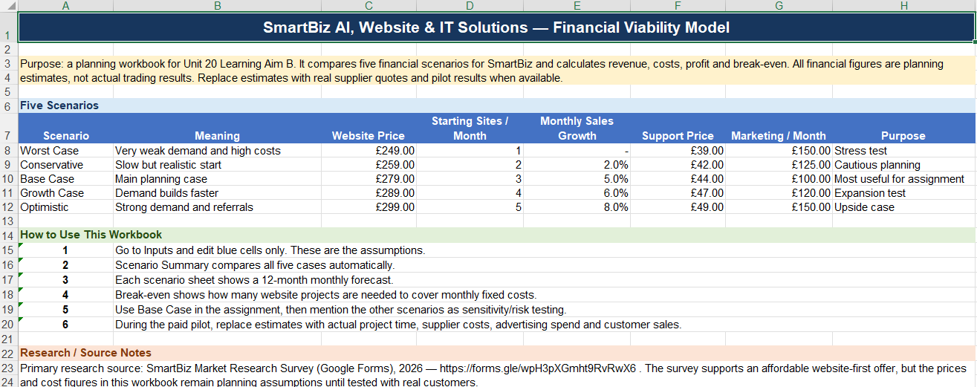

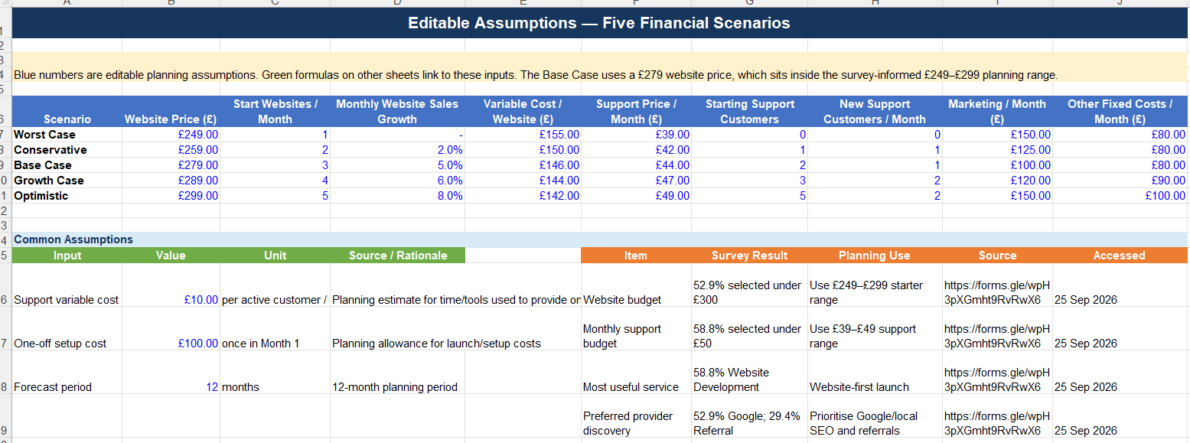
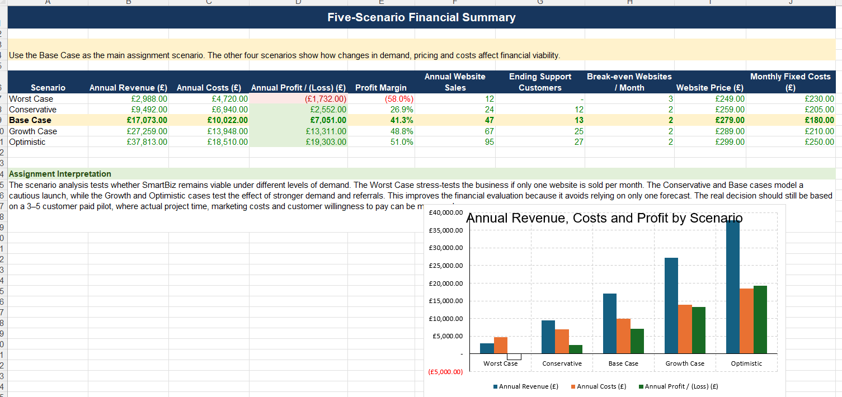
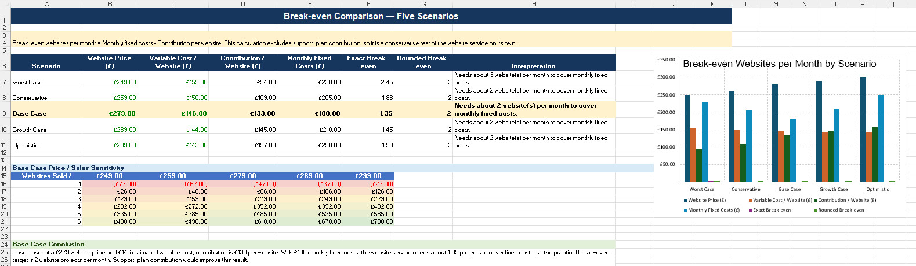
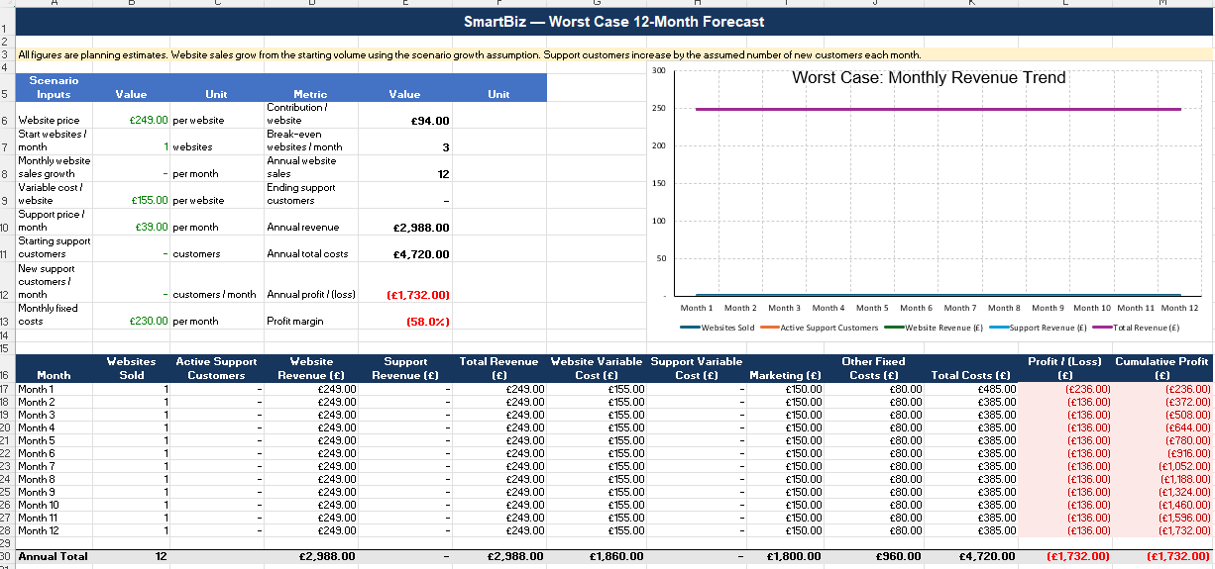

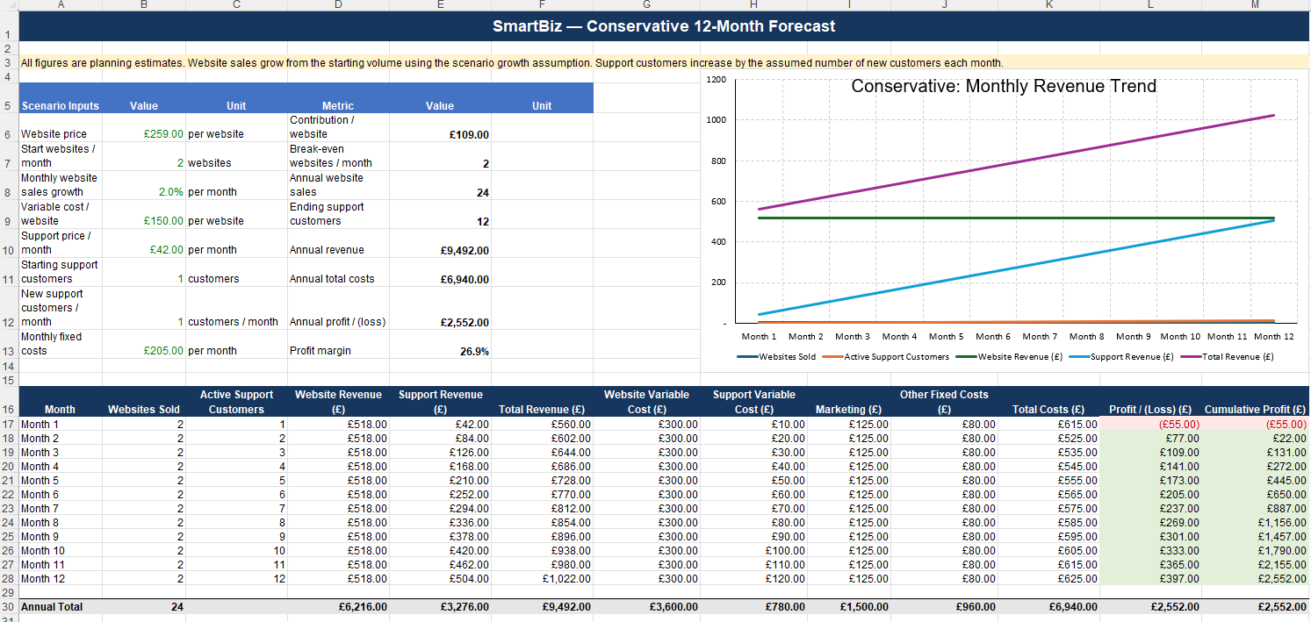
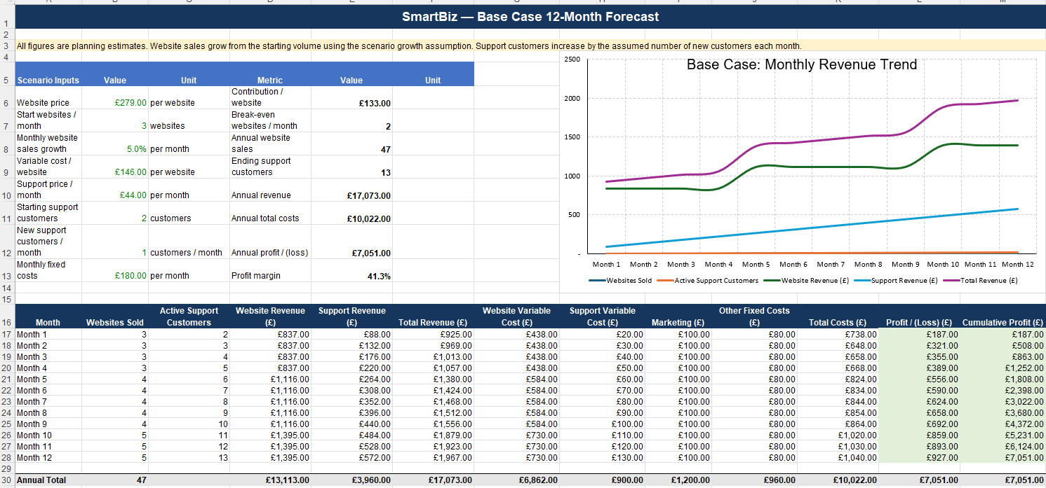
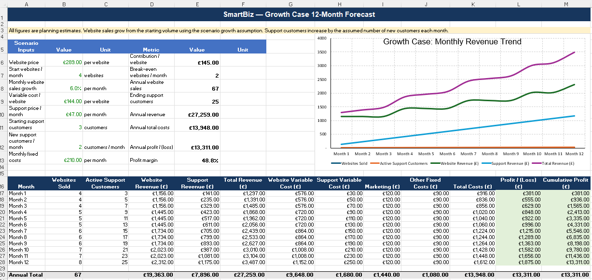
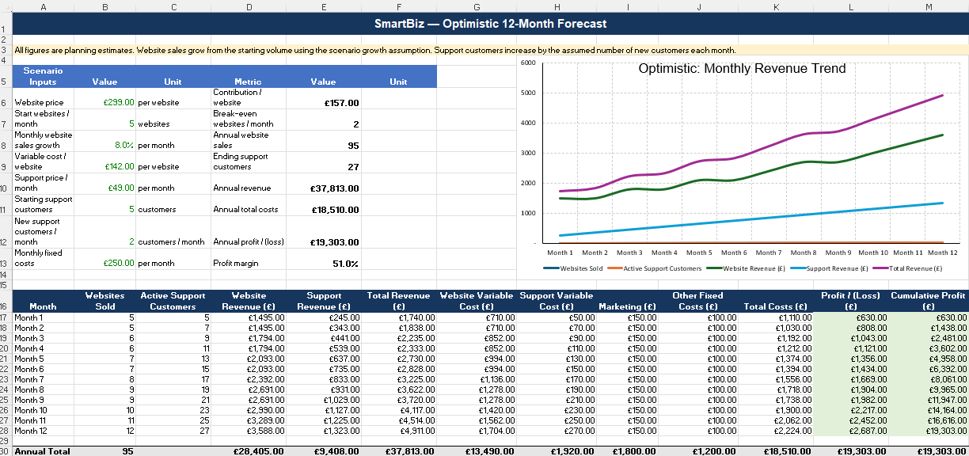

SmartBiz_Full_5_Scenario_Financial_Model.xlsx
References
Department for Business and Trade (2025) Business population estimates for the UK and regions 2025. Available at: https://www.gov.uk/government/statistics/business-population-estimates-2025/business-population-estimates-for-the-uk-and-regions-2025-statistical-release (Accessed: 11 September 2026).
Department for Business and Trade (2025) Understanding technology adoption among UK SMEs. Available at: https://www.gov.uk/government/publications/understanding-technology-adoption-among-uk-smes (Accessed: 11 September 2026).
Department for Business and Trade (2026) SME Digital Adoption Taskforce: 2026 update. Available at: https://www.gov.uk/government/publications/sme-digital-adoption-taskforce-2026-update (Accessed: 11 September 2026).
Department for Science, Innovation and Technology (2026) AI Adoption Research. Available at: https://www.gov.uk/government/publications/ai-adoption-research/ai-adoption-research (Accessed: 11 September 2026).
Information Commissioner’s Office (n.d.) Data protection principles - guidance and resources. Available at: https://ico.org.uk/for-organisations/uk-gdpr-guidance-and-resources/data-protection-principles/ (Accessed: 11 September 2026).
Wix (n.d.) AI Website Builder. Available at: https://www.wix.com/ai-website-builder (Accessed: 11 September 2026).
GoDaddy (n.d.) Website Builder - Create a Free Website. Available at: https://www.godaddy.com/en-uk/websites/website-builder (Accessed: 11 September 2026).
HubSpot (n.d.) CRM Software for Small Business. Available at: https://www.hubspot.com/products/crm/small-business (Accessed: 11 September 2026).
Pearson Education Limited (2021) BTEC Level 3 National Extended Diploma in Information Technology, Unit 20: Enterprise in IT, Learning Aim B, Specification Issue 6.
National Cyber Security Centre (2026) Small organisations guide to cyber security. (Accessed: 11 September 2026).
National Cyber Security Centre (n.d.) Cyber security advice for small to medium sized organisations. (Accessed: 11 September 2026).
Information Commissioner's Office (n.d.) Artificial intelligence. (Accessed: 11 September 2026).
Information Commissioner's Office (n.d.) Guidance on AI and data protection. (Accessed: 11 September 2026).
Information Commissioner's Office (n.d.) AI and data protection risk toolkit. (Accessed: 11 September 2026).
OpenAI (n.d.) OpenAI for small business. (Accessed: 11 September 2026).
Microsoft (n.d.) Microsoft 365 Copilot for Small and Medium Business. (Accessed: 11 September 2026).
Microsoft (n.d.) Microsoft 365 Copilot plans and pricing - AI for business. (Accessed: 11 September 2026).
Zapier (2026) How to use AI for business automation (without a dedicated tech team). (Accessed: 11 September 2026).
Google (n.d.) Get started with Google Business Profile. (Accessed: 11 September 2026).
GOV.UK (n.d.) Online and distance selling. (Accessed: 11 September 2026).
Business.gov.uk (n.d.) How to start a business in the UK. (Accessed: 11 September 2026).
HubSpot (2026) What is a marketing plan and how to write one. (Accessed: 11 September 2026).
Department for Business and Trade (2025) Business population estimates 2025. Available at: GOV.UK – Business population estimates 2025 (Accessed: 25 September 2026). GOV.UK
Department for Business and Trade (2025) Business population estimates for the UK and regions 2025: statistical release. Available at: GOV.UK – Statistical release (Accessed: 25 September 2026). GOV.UK
Department for Business and Trade (2025) Understanding technology adoption among UK SMEs. Available at: GOV.UK – Understanding technology adoption among UK SMEs (Accessed: 25 September 2026). GOV.UK
Department for Business and Trade (2025) SME Digital Adoption Taskforce: final report. Available at: GOV.UK – SME Digital Adoption Taskforce final report (Accessed: 25 September 2026). GOV.UK
Department for Business and Trade (2026) SME Digital Adoption Taskforce: 2026 update. Available at: GOV.UK – SME Digital Adoption Taskforce 2026 update (Accessed: 25 September 2026). GOV.UK
Department for Science, Innovation and Technology (2026) AI Adoption Research. Available at: GOV.UK – AI Adoption Research (Accessed: 25 September 2026). GOV.UK
Department for Science, Innovation and Technology (2026) AI Adoption Research: findings. Available at: GOV.UK – AI Adoption Research findings (Accessed: 25 September 2026). GOV.UK
Department for Science, Innovation and Technology (2026) Cyber security breaches survey 2025/2026. Available at: GOV.UK – Cyber security breaches survey (Accessed: 25 September 2026). GOV.UK
National Cyber Security Centre (2026) Small organisations guide to cyber security. Available at: NCSC – Small organisations cyber security guide (Accessed: 25 September 2026). National Cyber Security Centre
National Cyber Security Centre (n.d.) Cyber security advice for small to medium sized organisations. Available at: NCSC – SME cyber security advice (Accessed: 25 September 2026). National Cyber Security Centre
Information Commissioner’s Office (2026) A guide to the data protection principles. Available at: ICO – Data protection principles (Accessed: 25 September 2026). ICO
Information Commissioner’s Office (n.d.) Data protection principles: guidance and resources. Available at: ICO – Data protection guidance (Accessed: 25 September 2026). ICO
Information Commissioner’s Office (2026) Direct marketing guidance. Available at: ICO – Direct marketing guidance (Accessed: 25 September 2026). ICO
Information Commissioner’s Office (n.d.) Direct marketing and privacy and electronic communications. Available at: ICO – Direct marketing and PECR (Accessed: 25 September 2026). ICO
Information Commissioner’s Office (2026) Guidance on direct marketing using electronic mail. Available at: ICO – Electronic mail marketing guidance (Accessed: 25 September 2026). ICO
Information Commissioner’s Office (n.d.) Electronic and telephone marketing. Available at: ICO – Electronic and telephone marketing (Accessed: 25 September 2026). ICO
Information Commissioner’s Office (n.d.) Business-to-business marketing. Available at: ICO – B2B marketing guidance (Accessed: 25 September 2026). ICO
Information Commissioner’s Office (n.d.) Plan direct marketing. Available at: ICO – Planning direct marketing (Accessed: 25 September 2026). ICO
Information Commissioner’s Office (n.d.) Cookies and similar technologies. Available at: ICO – Cookies guidance (Accessed: 25 September 2026). ICO
Information Commissioner’s Office (2026) Direct marketing advice generator. Available at: ICO – Direct marketing advice generator (Accessed: 25 September 2026). ICO
UK Government (2018) Data Protection Act 2018. Available at: GOV.UK – Data Protection Act 2018 (Accessed: 25 September 2026). GOV.UK
UK Government (n.d.) Marketing and advertising: the law. Available at: GOV.UK – Marketing and advertising law (Accessed: 25 September 2026). GOV.UK
UK Government (n.d.) Marketing and advertising: direct marketing. Available at: GOV.UK – Direct marketing law (Accessed: 25 September 2026). GOV.UK
UK Government (n.d.) Marketing and advertising: advertising codes of practice. Available at: GOV.UK – Advertising codes of practice (Accessed: 25 September 2026). GOV.UK
UK Government (n.d.) How copyright protects your work. Available at: GOV.UK – Copyright guidance (Accessed: 25 September 2026). GOV.UK
UK Government (n.d.) Write a business plan. Available at: GOV.UK – Write a business plan (Accessed: 25 September 2026). GOV.UK
UK Government (n.d.) Set up a business. Available at: GOV.UK – Set up a business (Accessed: 25 September 2026). GOV.UK
UK Government (n.d.) Set up as a sole trader. Available at: GOV.UK – Sole trader guidance (Accessed: 25 September 2026). GOV.UK
UK Government (n.d.) Set up a limited company. Available at: GOV.UK – Limited company guidance (Accessed: 25 September 2026). GOV.UK
Business.gov.uk (n.d.) Setting up as a formal business. Available at: Business.gov.uk – Setting up a formal business (Accessed: 25 September 2026). Business Growth Service
Office for National Statistics (2026) Business insights and impact on the UK economy: 24 September 2026. Available at: ONS – Business insights September 2026 (Accessed: 25 September 2026). Office for National Statistics
Office for National Statistics (2026) Business insights and impact on the UK economy dataset. Available at: ONS – BICS dataset (Accessed: 25 September 2026). Office for National Statistics
Bank of England (2026) Monetary Policy Report – July 2026. Available at: Bank of England – Monetary Policy Report (Accessed: 25 September 2026). Bank of England
World Wide Web Consortium (2024) Web Content Accessibility Guidelines (WCAG) 2.2. Available at: W3C – WCAG 2.2 (Accessed: 25 September 2026). W3C
World Wide Web Consortium (n.d.) What’s New in WCAG 2.2. Available at: W3C – What's New in WCAG 2.2 (Accessed: 25 September 2026). W3C
OWASP Foundation (2025) OWASP Top 10: 2025. Available at: OWASP – Top 10: 2025 (Accessed: 25 September 2026). OWASP Top 10
Google (n.d.) Search Engine Optimization (SEO) Starter Guide. Available at: Google – SEO Starter Guide (Accessed: 25 September 2026). Google for Developers
Google (n.d.) Google Search documentation. Available at: Google – Search documentation (Accessed: 25 September 2026). Google for Developers
Google (n.d.) Google Search Essentials. Available at: Google – Search Essentials (Accessed: 25 September 2026). Google for Developers
Google (n.d.) Get your website on Google. Available at: Google – Get your website on Google (Accessed: 25 September 2026). Google for Developers
Google (n.d.) Google Search Central. Available at: Google Search Central (Accessed: 25 September 2026). Google for Developers
Google (n.d.) Get started with Google Business Profile. Available at: Google – Business Profile (Accessed: 25 September 2026). Google Help
Google (n.d.) Google Business Profile Learning Centre. Available at: Google – Business Profile Learning Centre (Accessed: 25 September 2026). Google Help
Google (n.d.) Google Analytics Help. Available at: Google – Analytics Help (Accessed: 25 September 2026). Google Help
Google (n.d.) Google Ads: campaign and advertising solutions. Available at: Google Ads – Advertising solutions (Accessed: 25 September 2026). Google
Wix (n.d.) AI Website Builder. Available at: Wix – AI Website Builder (Accessed: 25 September 2026). wix.com
Wix (n.d.) Creating an AI-generated site. Available at: Wix – Creating an AI-generated site (Accessed: 25 September 2026). Wix Help Center
GoDaddy (n.d.) Website Builder. Available at: GoDaddy – Website Builder (Accessed: 25 September 2026). GoDaddy
GoDaddy (n.d.) Airo AI Builder. Available at: GoDaddy – Airo (Accessed: 25 September 2026). GoDaddy
GoDaddy (n.d.) Plans and pricing. Available at: GoDaddy – Plans and pricing (Accessed: 25 September 2026). GoDaddy
HubSpot (n.d.) Free CRM software for startups and small businesses. Available at: HubSpot – CRM (Accessed: 25 September 2026). HubSpot
HubSpot (n.d.) Marketing Automation Software. Available at: HubSpot – Marketing Automation (Accessed: 25 September 2026). HubSpot
HubSpot (n.d.) HubSpot products. Available at: HubSpot – Products (Accessed: 25 September 2026). HubSpot
Squarespace (n.d.) Website Builder. Available at: Squarespace – Website Builder (Accessed: 25 September 2026). Squarespace
Shopify (n.d.) Shopify pricing. Available at: Shopify UK – Pricing (Accessed: 25 September 2026). Shopify
WordPress.com (n.d.) Free website builder. Available at: WordPress.com – Free Website Builder (Accessed: 25 September 2026). WordPress.com
Microsoft (2026) Microsoft 365 plans and pricing for business. Available at: Microsoft – Microsoft 365 Business pricing (Accessed: 25 September 2026). Microsoft
Amazon Web Services (n.d.) What is cloud computing? Available at: AWS – What is cloud computing? (Accessed: 25 September 2026). AWS Documentation
Mailchimp (n.d.) Marketing automation tools. Available at: Mailchimp – Marketing Automation (Accessed: 25 September 2026). Mailchimp
UK Government (2003) The Privacy and Electronic Communications (EC Directive) Regulations 2003. Available at: Legislation.gov.uk – PECR 2003 (Accessed: 25 September 2026).
Asim, S. (2026) SmartBiz Market Research Survey [Google Forms questionnaire]. Available at: https://forms.gle/wpH3pXGmht9RvRwX6 (Accessed: 25 September 2026).
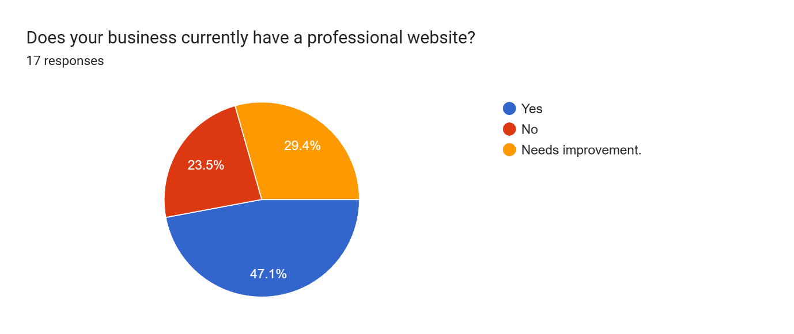
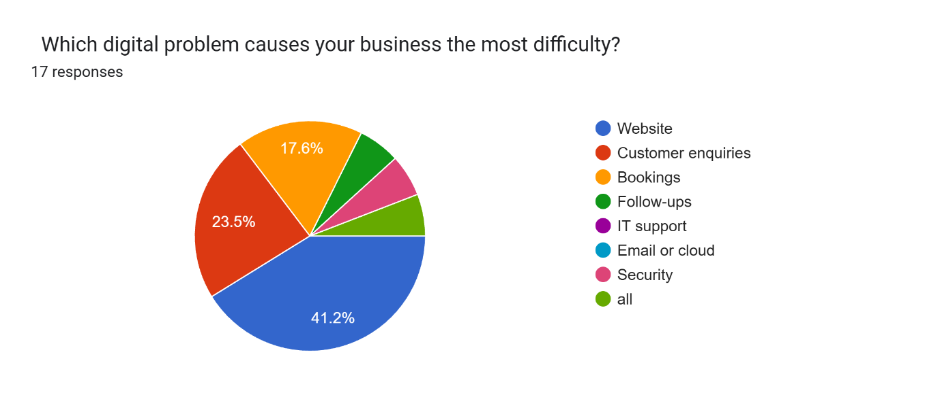
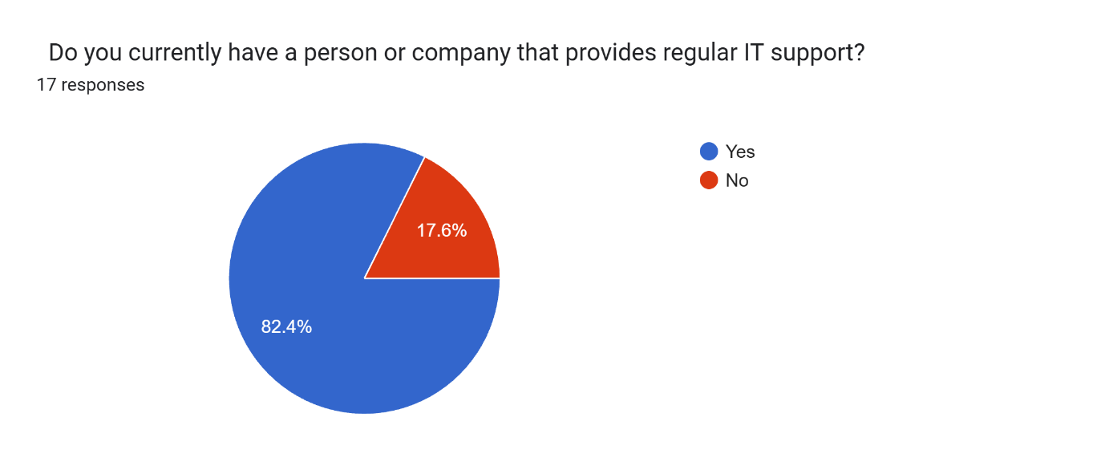
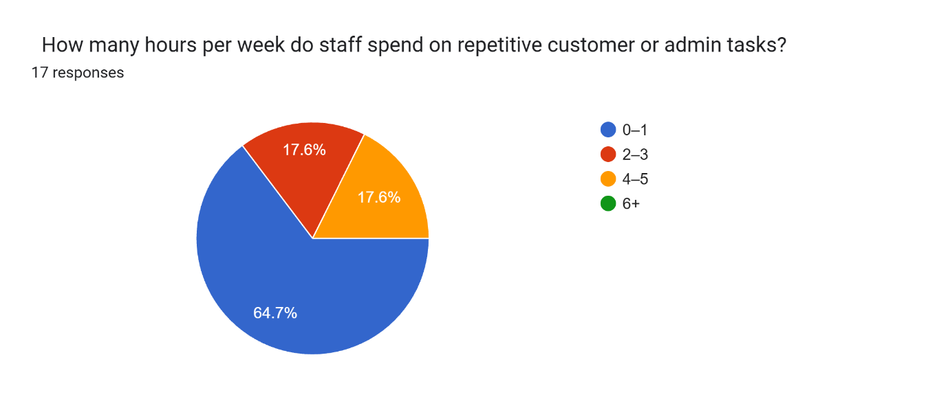
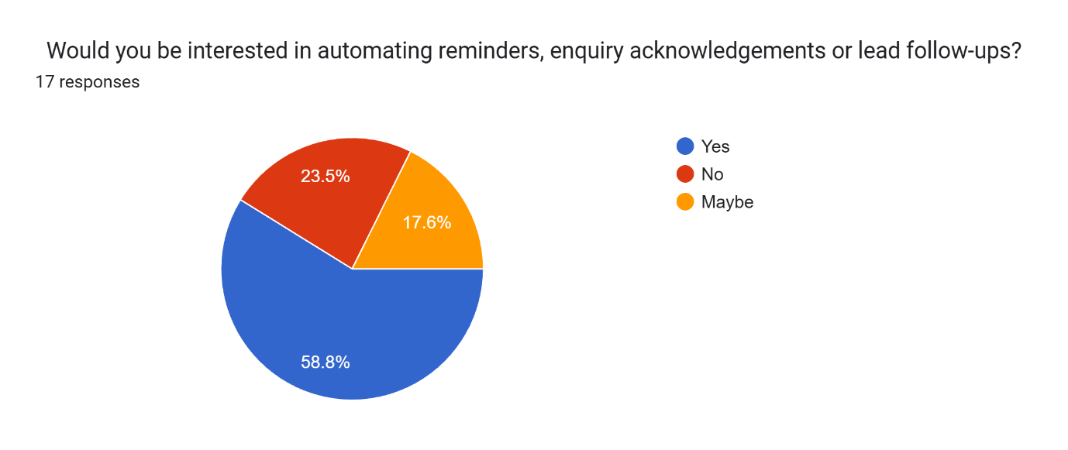
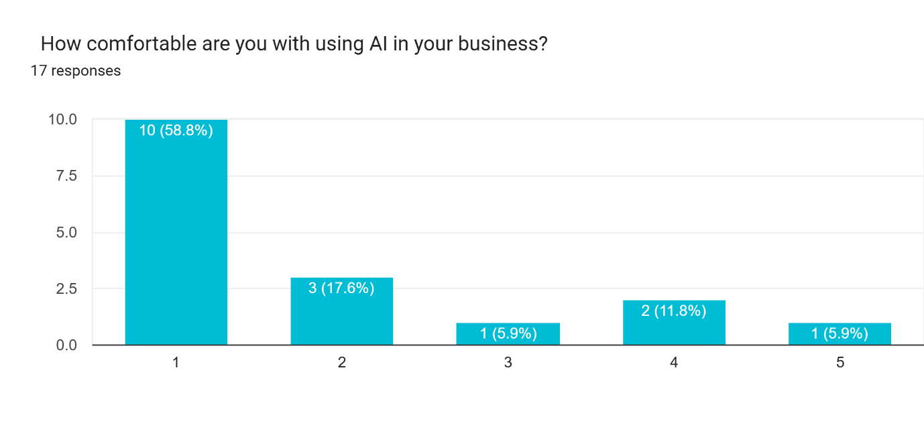
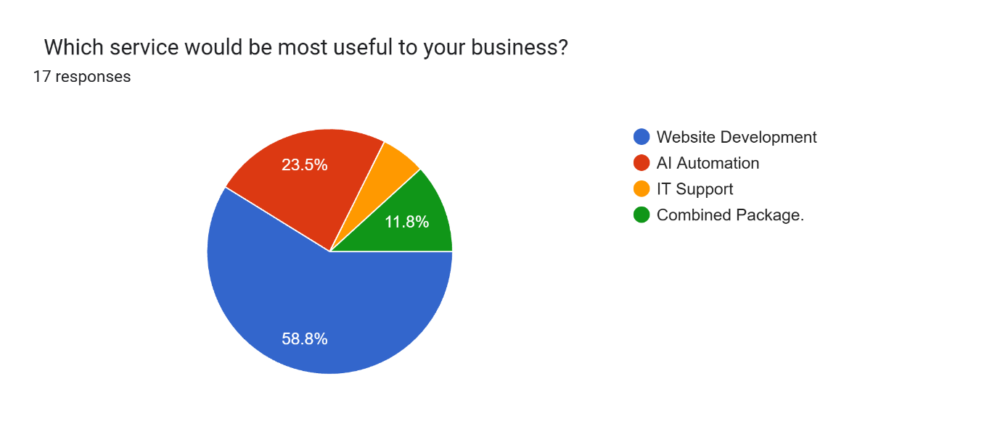
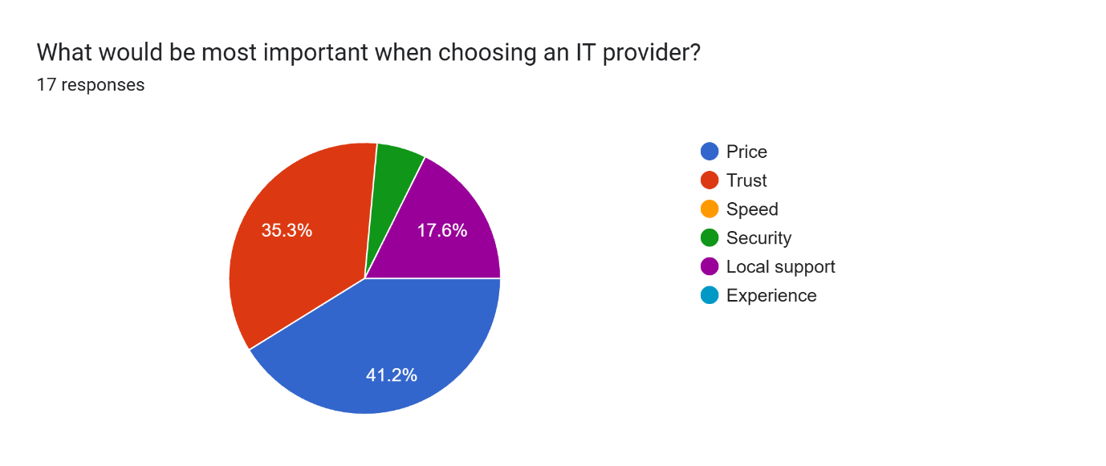
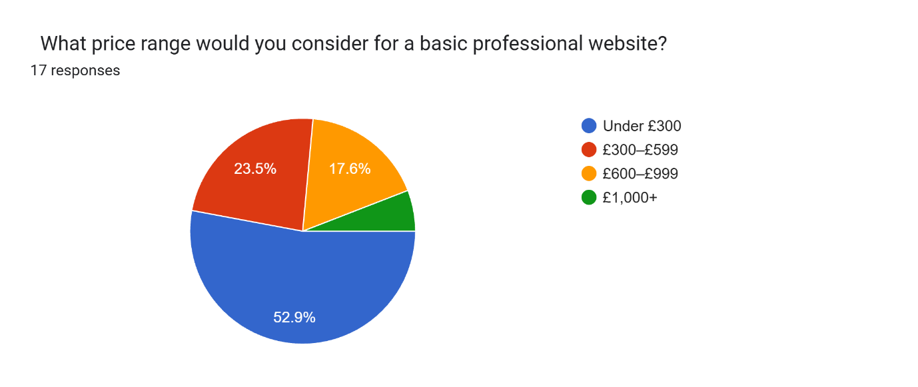
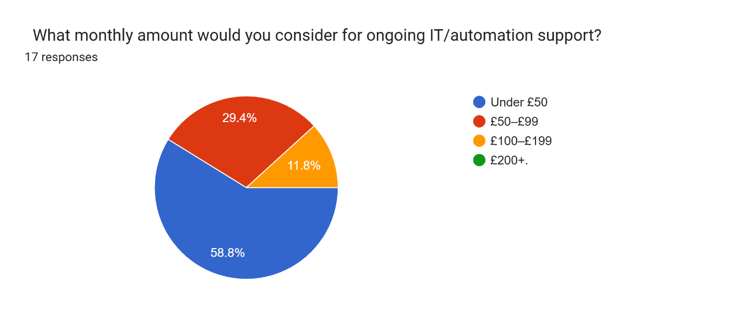
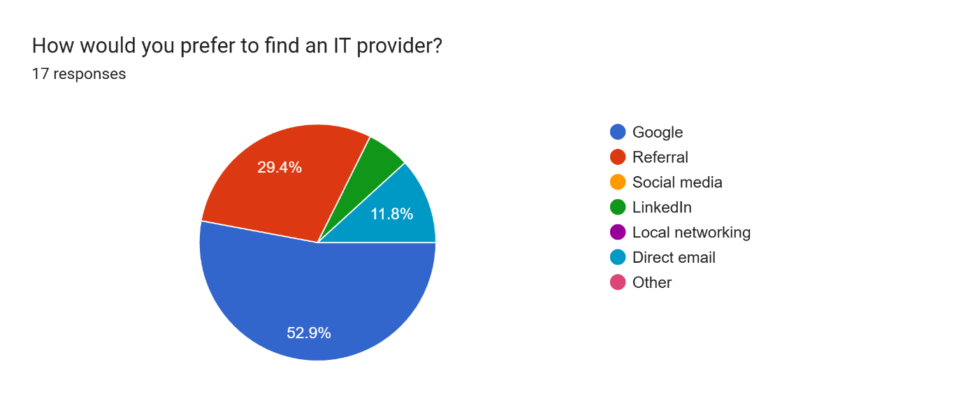
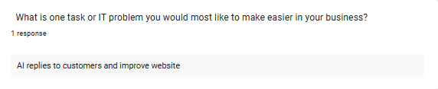
smartbiz.xlsx

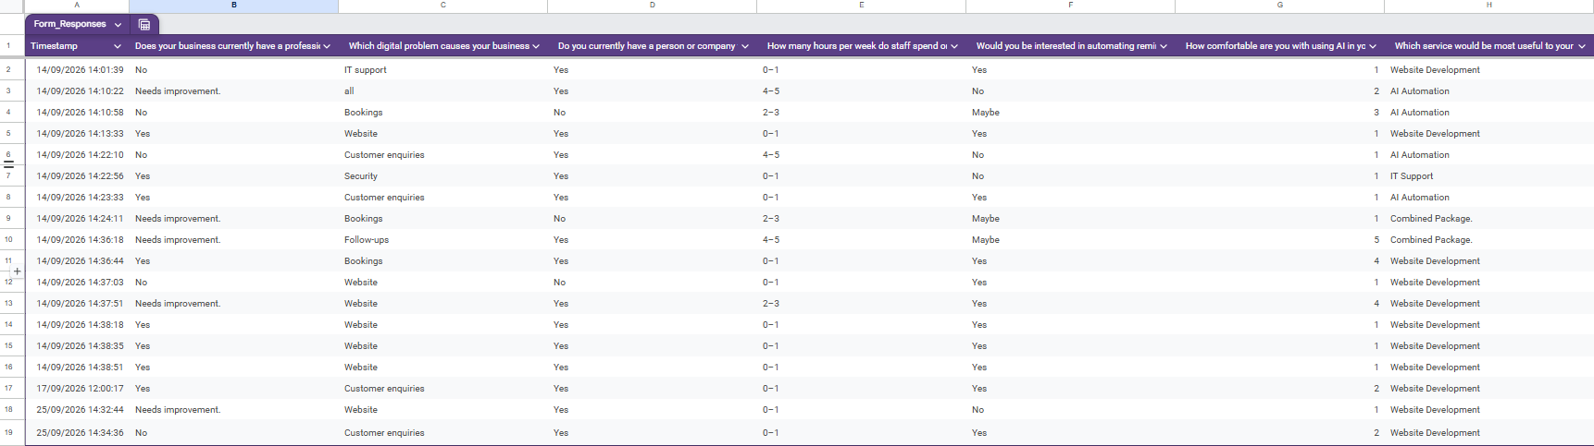
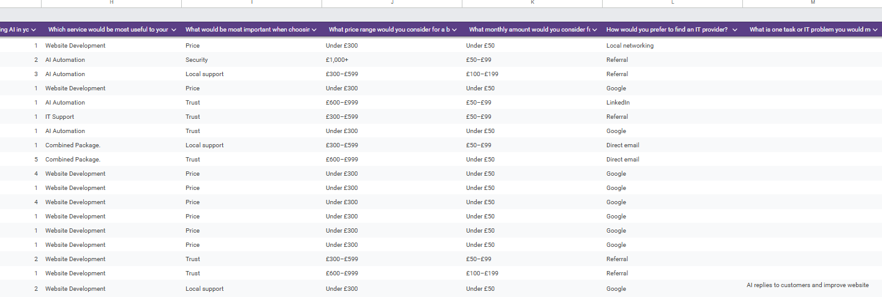
SmartBiz_Market_Research_Survey.xlsx

