Unit 21 – Technology business Learning Aim D
Business Plan for iPhone 18 Pro Max

1. Introduction
I am working as a Marketing Apprentice at Leyton Tech Corporation. I am working on a new technology project. Now I need to create a business plan for my product, the iPhone 18 Pro Max. This business plan will explain how the business will start and how it will make money. It will show market research, competitor information, financial plans, and possible risks. The aim of this plan is to show investors that the iPhone 18 Pro Max is a good business idea and can be successful in the smartphone market.

2. Business Idea
The business idea is to introduce and sell a new smartphone called the iPhone 18 Pro Max. This phone will focus on high performance, strong security and good camera quality. The product will provide Advanced camera system, long battery life, Fast processor, Secure Face ID and Premium design
I selected this idea because smartphones are used every day by millions of people. Apple products are trusted and have a strong customer base. There is always interest when a new iPhone model is released.
My skills that will help with this business include:
- Understanding customer needs
- Basic knowledge of costs and profit
- Communication skills
- Research skills

3. Aims and Objectives
Main Aim:
To launch the iPhone 18 Pro Max successfully and generate profit.
Short-Term Objectives:
- Achieve sales of 200 units per month
- Cover all costs within the first month
- Create strong awareness through marketing
Long-Term Objectives:
- Increase sales each year
- Improve brand position in the market
- Maintain customer satisfaction

4. Target Market
The target customers are:
- Young adults (18–40 years old)
- Professionals
- Technology users who prefer premium phones
Customers want:
- Clear photos and videos
- Long battery performance
- Fast speed
- Secure device
This product meets the need for a reliable and powerful smartphone.

5. Market Research Summary
Primary Research:
A small survey showed that most people value:
- Camera quality
- Battery life
- Fast performance
Many respondents said they would consider buying the new model.
Secondary Research:
Online data shows Apple sells millions of phones each year. The premium smartphone market continues to grow.
What the Research Shows:
There is strong demand for high-quality smartphones. Customers are willing to pay more for better features.

6. Competitor Review
Main Competitor: Samsung Galaxy Ultra
Samsung Strengths:
- Slightly lower price
- Strong camera
- Large screen
Samsung Weaknesses:
- Different operating system
- Not connected to Apple ecosystem
Comparison

Feature | iPhone 18 Pro Max | Samsung Galaxy Ultra
price | £1,399 | £1,199
Security | Face ID | Fingerprint
System | Ios | Android

Unique Selling Point (USP)
The USP of the iPhone 18 Pro Max is:
- Easy integration with other Apple devices
- Strong brand trust
- High security

7. Marketing Plan
Promotion Methods:
- Social media advertising
- Online campaigns
- Influencer promotion
- Company website
Why This Works:
The target market uses social media daily, so online promotion is effective.
How Customers Will Be Attracted:
- Showing real camera results
- Highlighting battery life
- Emphasising security features

8. Financial Plan
Start-Up Costs:
Fixed costs: £20,000
Running Costs:
Variable cost per unit: £1,100
Pricing Strategy:
Selling price: £1,399
This follows a premium pricing strategy.
Sales Forecast:
Estimated sales: 200 units per month

Break-even Summary
Break-even formula:
Fixed Costs ÷ Selling Price − Variable Cost
£20,000 ÷ £1,399 − £1,100
= 67 units
The business must sell 67 units to cover all costs.
Since expected sales are 200 units, the business will make profit.

Effect of Changing Revenue and Costs
If the price is reduced:
- Break-even point increases
- Profit decreases
If costs increase:
- Break-even increases
- Business risk becomes higher
This shows that controlling costs and pricing is important.

9. Resources Required
Physical Resources:
- Production facilities
- Warehousing
- Office space
Human Resources:
- Engineers
- Marketing staff
- Sales team
Financial Resources:
- Investment capital
- Marketing budget

10. Risks and Solutions
Risk 1: Strong competition
Solution: Focus on quality and branding
Risk 2: Lower than expected sales
Solution: Improve promotion or adjust pricing
Risk 3: Increase in production costs
Solution: Negotiate with suppliers

11. Justification of Business Decisions
The iPhone 18 Pro Max is likely to succeed because:
- Apple has strong brand loyalty
- Market research shows demand
- Break-even point is low 67 units
- Expected sales are much higher than break-even
The margin of safety reduces financial risk.
If sales fall, the company can:
- Reduce costs
- Adjust price
- Increase marketing
This makes the business plan realistic and financially secure.

12. Action Plan
Task | Decline | Responsibility
Finish market research | Week 1 | Marketing Team
Finalise product design and features | Week 2 | Product Development Team
Plan marketing strategy and advertising | Week 3 | Marketing Team
Set price and financial plan | Week 3 | Finance Team
Prepare product launch campaign | Week 4 | Marketing Team
Launch the product in the market | Week 5 | Sales Team

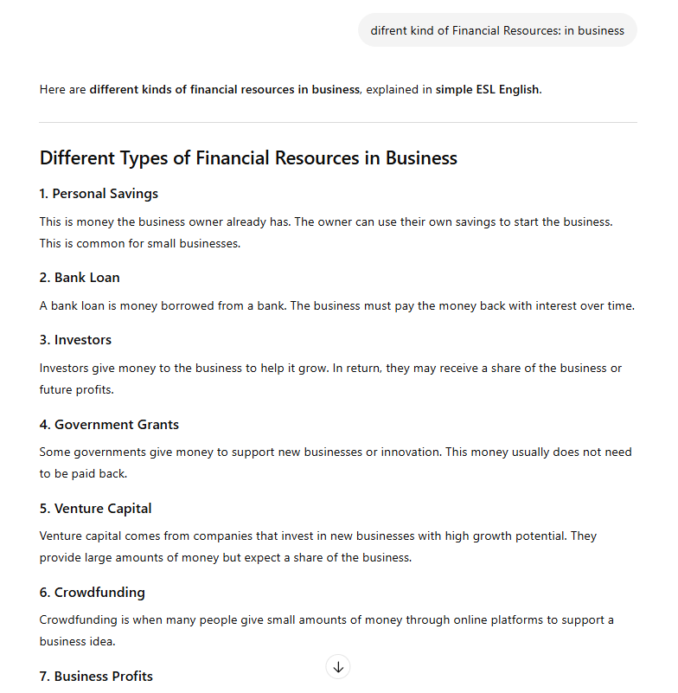
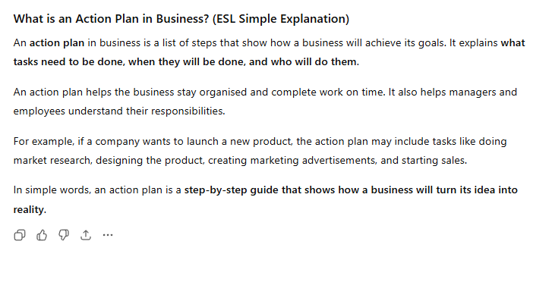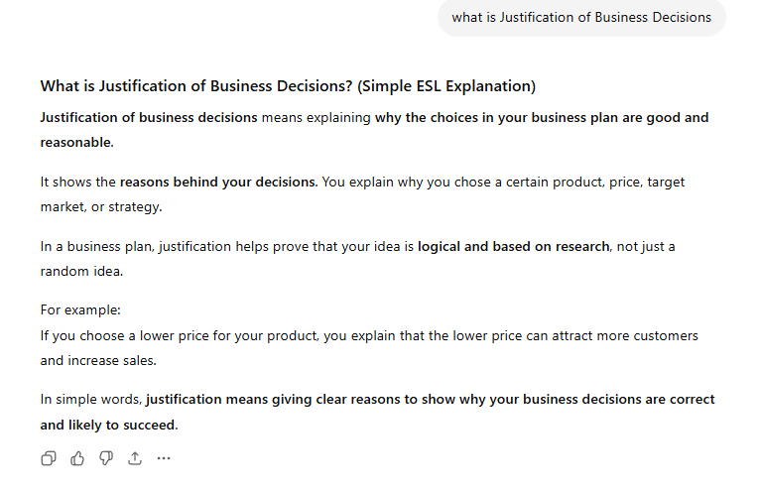
Business Gateway (2026) Business plan template for idea. Available at: https://www.bgateway.com/resources/starting-a-business/business-plan-template (Accessed: 20 February 2026).
Apple Inc. (2026) Business Plan for Startups. Available at: https://apps.apple.com/gb/app/business-plan-for-startups/id400755737 (Accessed: 3 March 2026).

